**Intro to Database Replication (Distributed Systems Series)**

The speaker explains **why replication is critical** in distributed systems before diving deeper into the topic in future videos.

**Why Replication Matters:**

* **Single database setup** (1 server + 1 DB) is risky:
  + **Data loss risk:** Hardware failures, accidental damage (e.g., spilling coffee).
  + **Downtime:** If DB goes down, app stops functioning.
  + **Poor global performance:** Distant users (e.g., Australia) face high latency.
  + **Limited scalability:** Single DB can't handle growing user base.

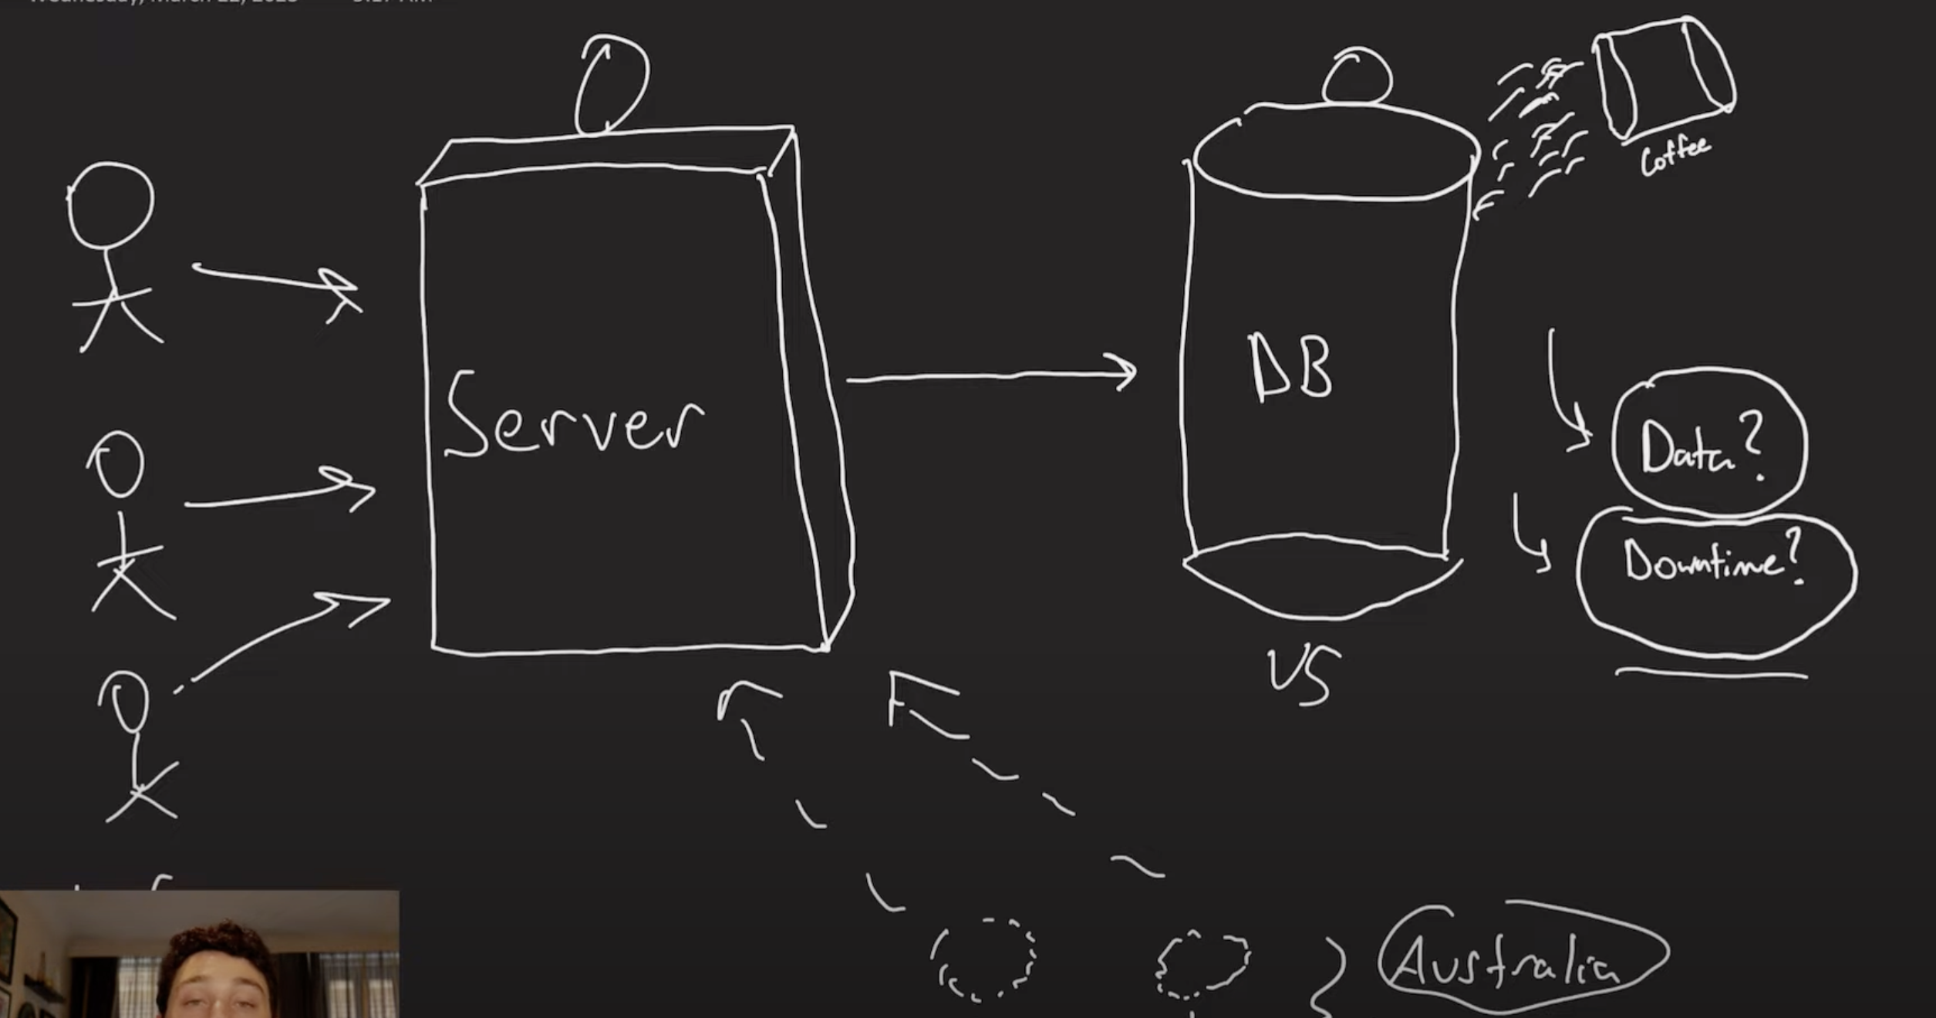

**Replication Solution:**

* **Replication** = making **multiple copies** of your data across DB nodes.
* Benefits:
  + **Fault tolerance:** If one DB fails, others continue serving requests.
  + **Higher throughput:** Users in different regions use separate DBs.
  + **Better latency:** Localized databases serve nearby users.

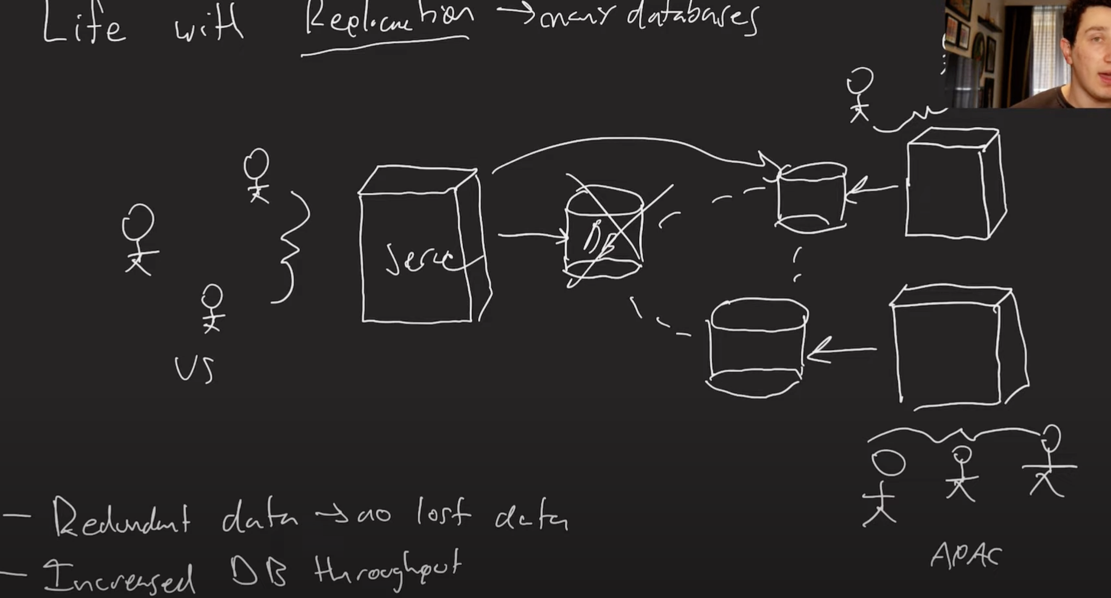

**Replication Models:**

1. **Synchronous Replication:**
   * Client writes → DB1 → DB2 → Acknowledge client.
   * Guarantees **strong consistency** (no stale reads).
   * Slower writes due to coordination across DBs.
2. **Asynchronous Replication:**
   * Client writes → DB1 acknowledges immediately.
   * DB1 updates DB2 **in background**.
   * Allows **eventual consistency** (some stale reads possible temporarily).
   * Faster writes but risk of inconsistent reads.

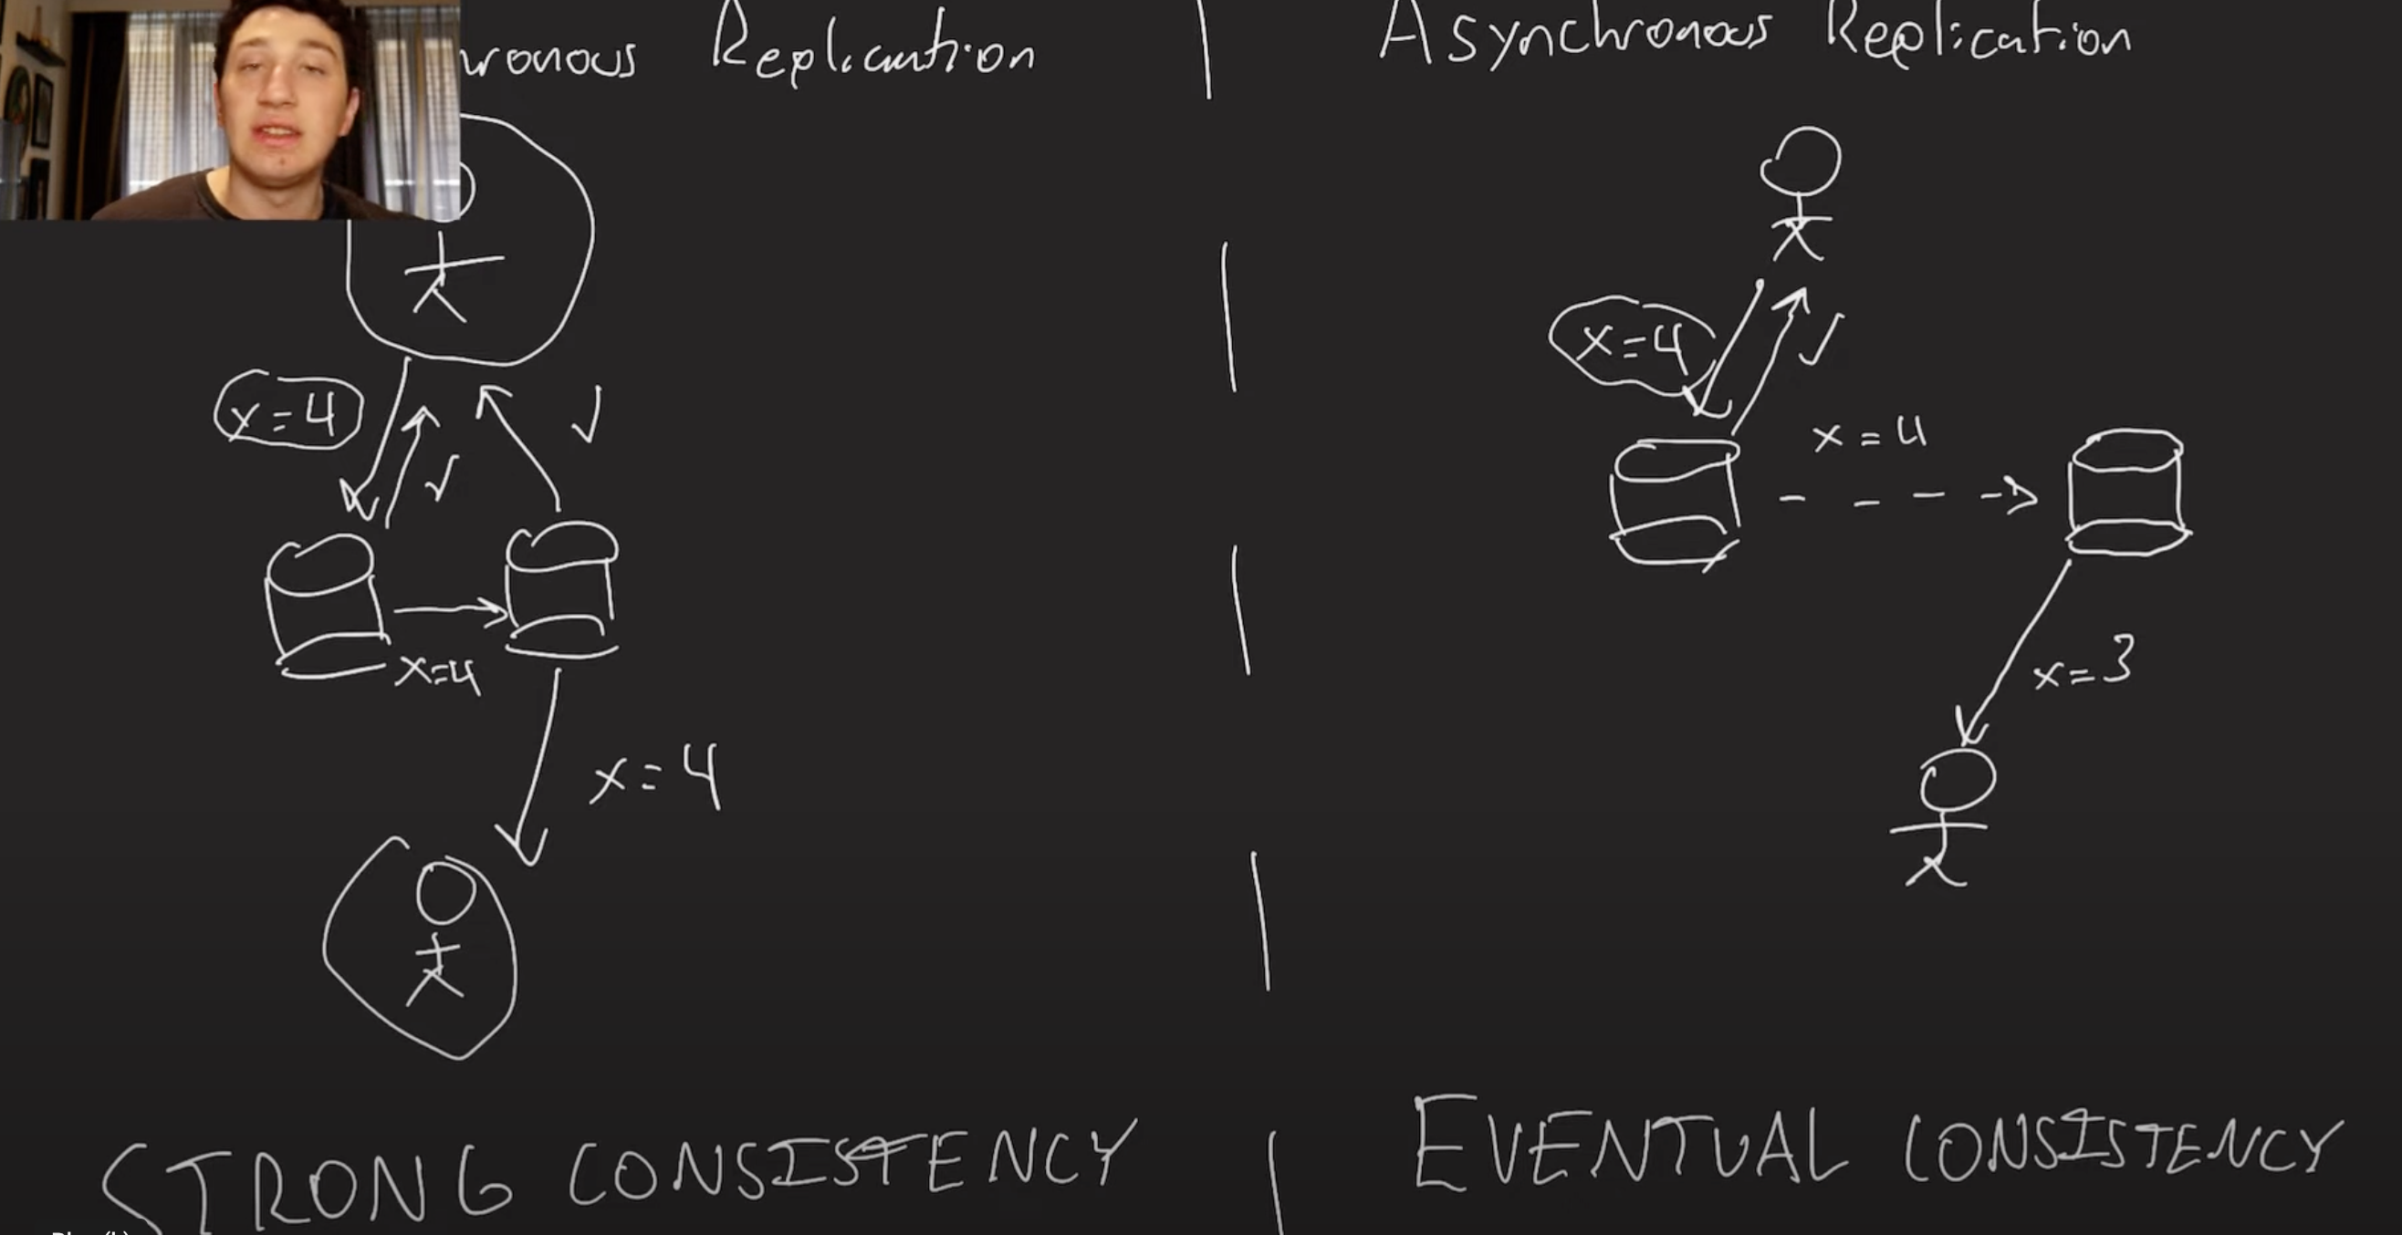

**Replication Methods:**

1. **SQL Statement Replication:**
   * Simply copy SQL commands.
   * Risky: Non-deterministic operations like time.now cause inconsistencies.
2. **Write-Ahead Log (WAL) Replication:**
   * Copy low-level disk changes.
   * Fast but incompatible across different DB engines (e.g., MySQL → Postgres).
3. **Replication Log (Logical Replication):**
   * Copy changes at the **row/ID level** (portable across DBs).
   * Reliable across DB types but adds some overhead.

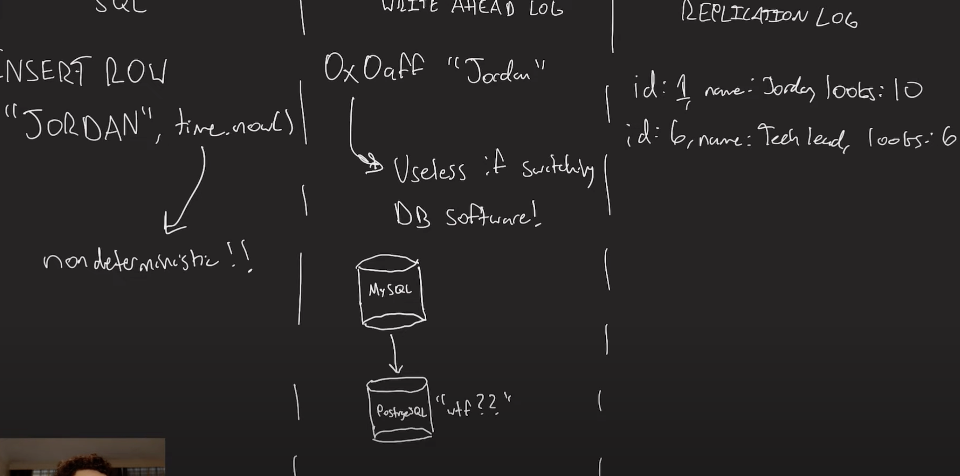

**Key Takeaway:**

Replication improves **fault tolerance, performance, and scalability** but introduces complexity around **consistency** and **write performance**.  
Every large system (Google, Facebook, etc.) relies on it.

**Video Summary: Making Eventual Consistency Less Painful**

The speaker discusses **eventual consistency** in distributed systems, why it's hard to handle, and practical ways to improve the user experience despite its challenges.

**Why Eventual Consistency Is Hard:**

* **Eventual consistency** means updates may take time to propagate to all database replicas.
* Clients may read **stale (outdated)** data, which can confuse users.
* Strong consistency isn’t practical for most large systems due to high latency and performance costs.

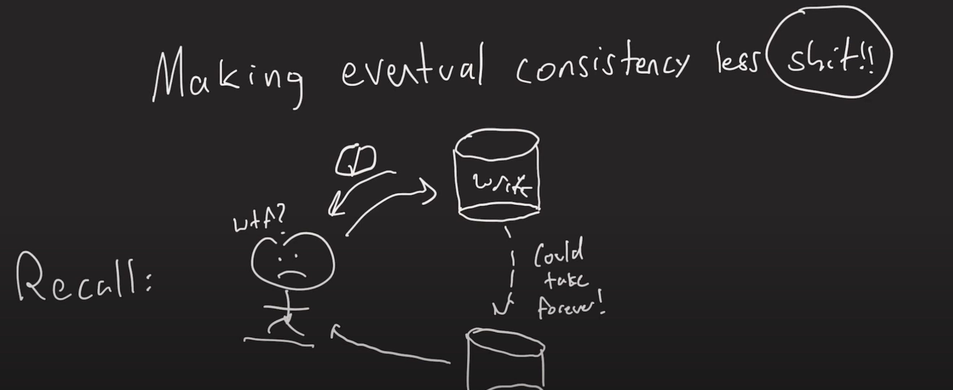

**Three Key Problems with Eventual Consistency (and Solutions):**

**1. Read-Your-Own-Writes Problem:**

* Example: A user updates their status but then doesn’t see the update immediately.
* **Solution:**
  + After writing, for a short period (e.g., 10 seconds), force reads from the same replica that accepted the write.
  + Optionally, use timestamps to check if other replicas have received updates (though timestamps can be tricky in distributed systems).

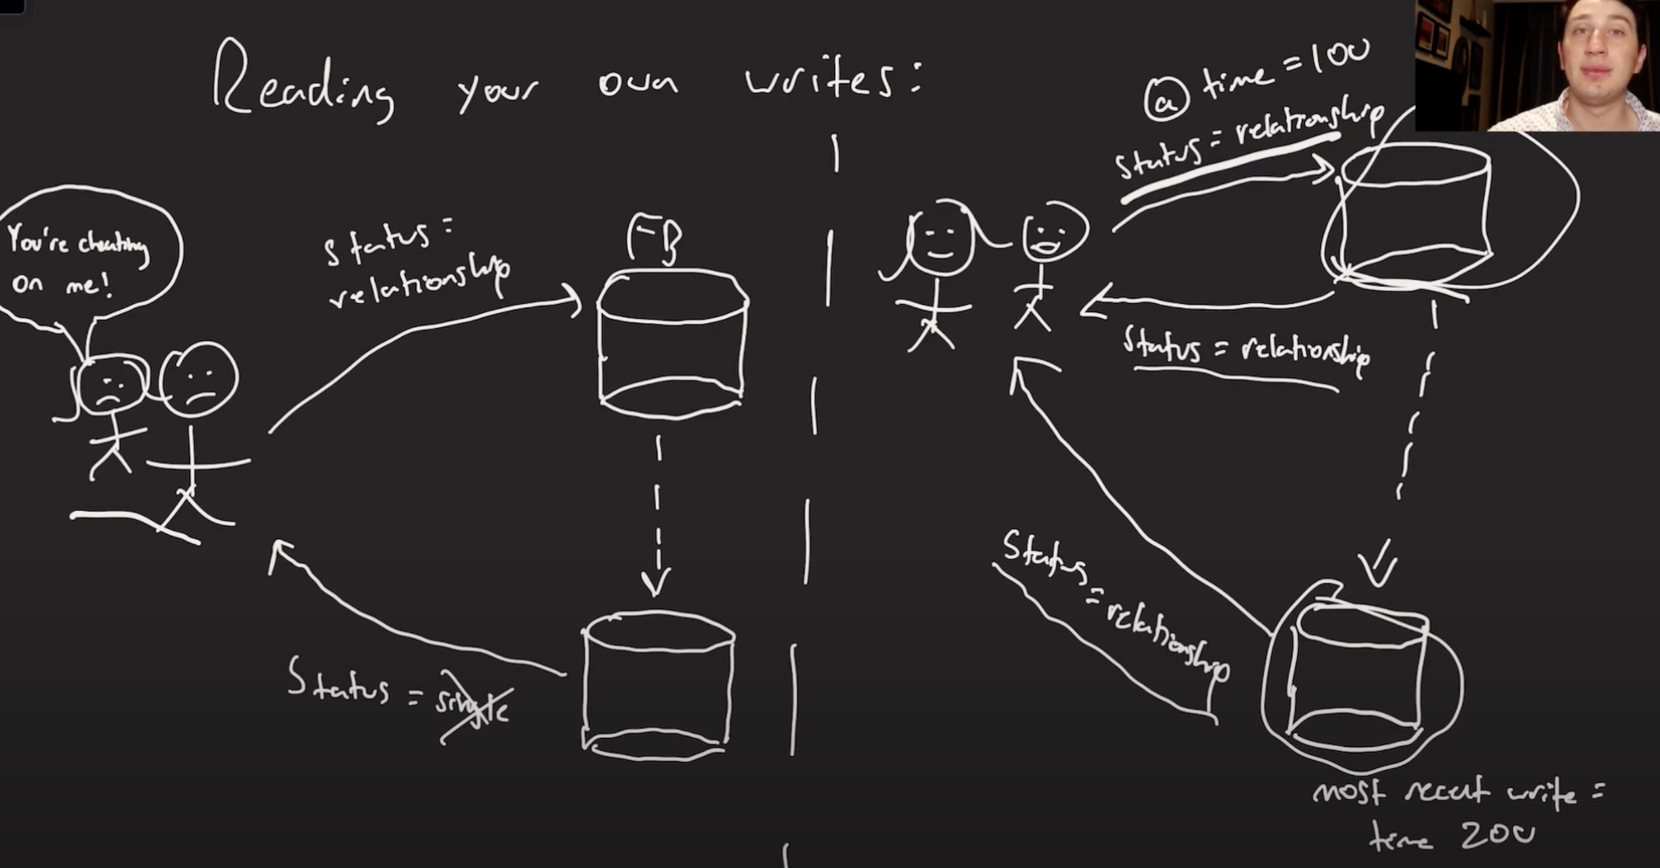

**2. Monotonic Reads (Avoiding "Time Travel"):**

* Example: In a group chat, the user may first read the newest message but then see older messages afterward when reading from different replicas.
* **Solution:**
  + Stick to reading from the **same replica** for a consistent experience.
  + Simple way: Use a function like userID mod number_of_replicas to consistently pick the same replica for a user.
  + Drawback: Doesn’t handle replica failures, but prevents "time travel" in reads.

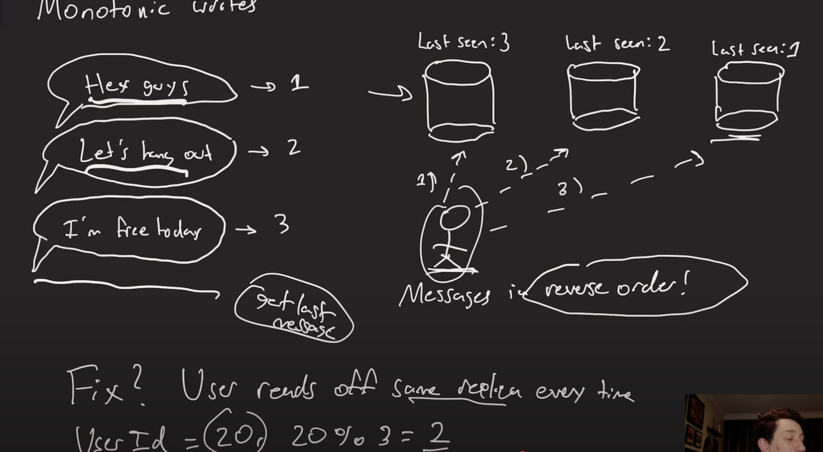

**3. Consistent Prefix Reads (Causal Consistency in Partitioned Systems):**

* Example: In a partitioned system, a reply like “Sure” may arrive before the original message “Want to grab lunch?” on different partitions.
* **Solution:**
  + Keep **causally related data** together in the same partition or replica when possible.
  + Example: Use a reply feature to force related messages into the same partition to preserve order.

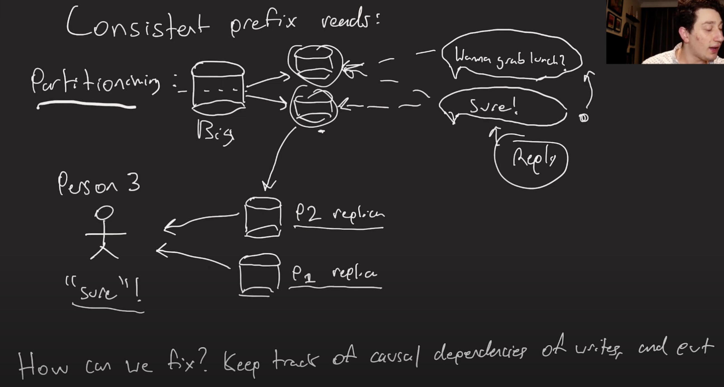

**Main Takeaway:**

* You **can’t eliminate** all stale reads in an eventually consistent system.
* However, using these techniques can **dramatically improve the user experience** by eliminating the most obvious and annoying inconsistencies.
* Future videos will cover **replication topologies** and how to design the right replication strategy for your needs.

**Video Summary: Single-Leader Replication Explained (Replication Topologies Series)**

The speaker explains **single-leader replication** in distributed systems, its benefits, failure scenarios, and challenges, setting the stage for deeper topics in upcoming videos.

**What is Single-Leader Replication?**

* A **replication schema** where all **writes** go to **one leader database**.
* **Followers** replicate data **asynchronously** from the leader.
* Clients can **read** from any replica (leader or followers), increasing **read throughput**.

**Benefits:**

1. **Durability:** Multiple database copies protect against data loss (failover-safe for followers).
2. **High Read Throughput:** Reads can be distributed across replicas near users (better latency, more concurrent reads).
3. **Simplicity:** Easy to implement by adding followers to an existing database.

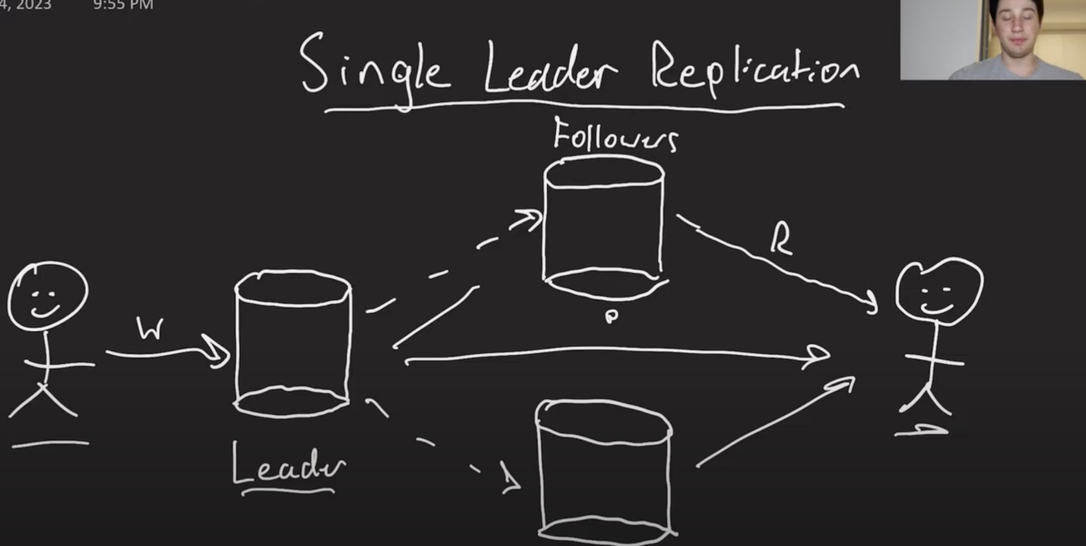

**Failure Scenarios & Challenges:**

1. **Follower Failure:**
   * Easy to recover: Followers can “catch up” using the replication log once restored.

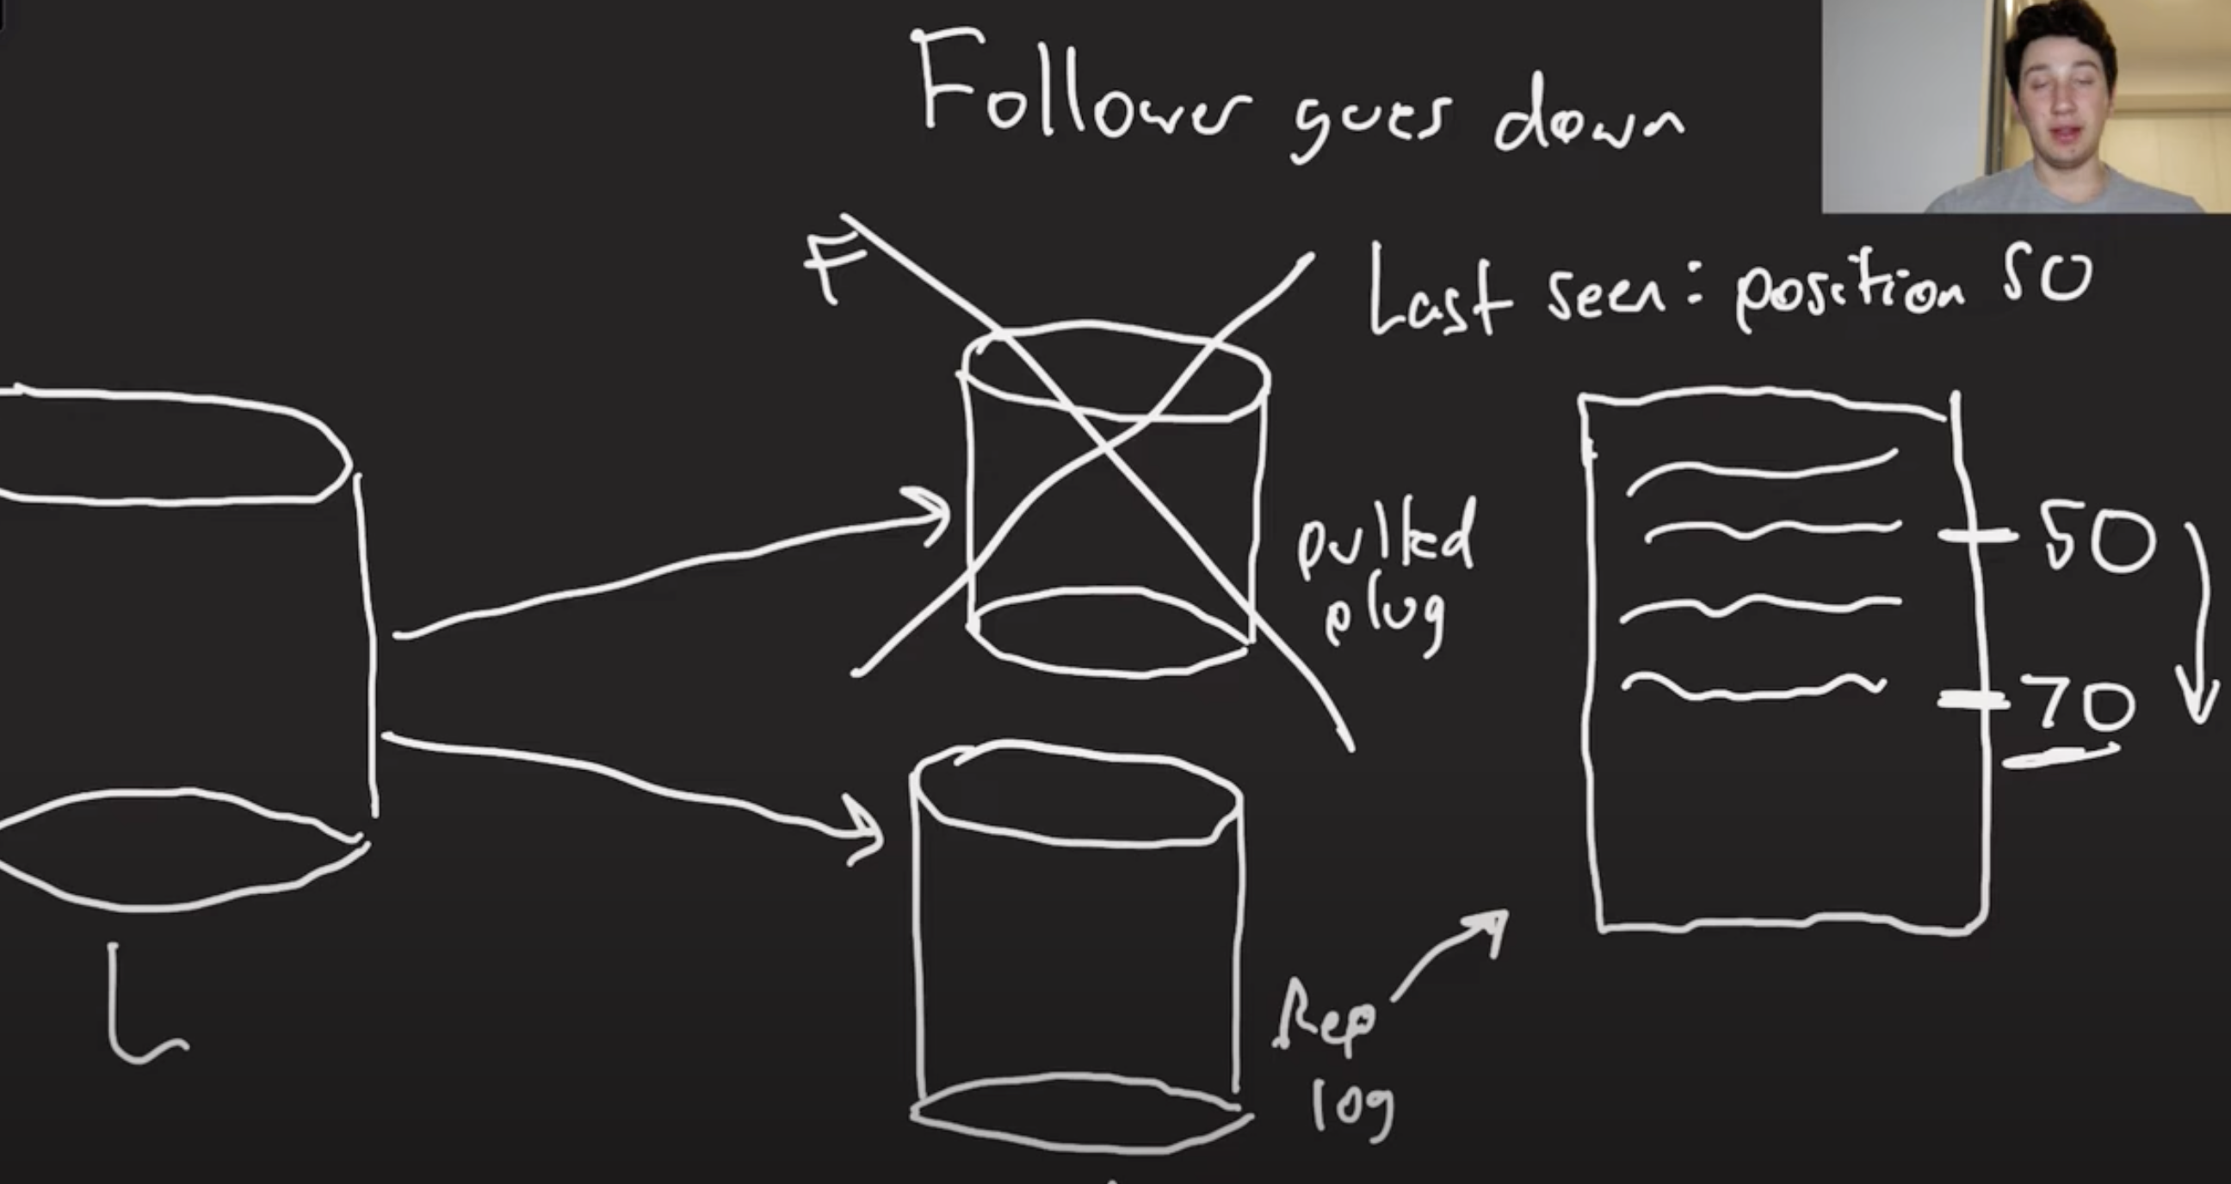

1. **Leader Failure:**  
   Three major problems:
   * **Network Partition / False Failure:**  
     A follower might falsely think the leader is down due to network issues, risking accidental failover.
   * **Lost Writes:**  
     If a leader crashes after accepting writes that didn’t replicate yet, those writes are permanently lost.
   * **Split Brain:**  
     Two nodes mistakenly act as leaders after network disruptions, causing conflicting writes and data corruption.

**Key Insight:**

* + **Leader failures are complex** and require **distributed consensus** (future topic) to safely elect a new leader and prevent split brain.

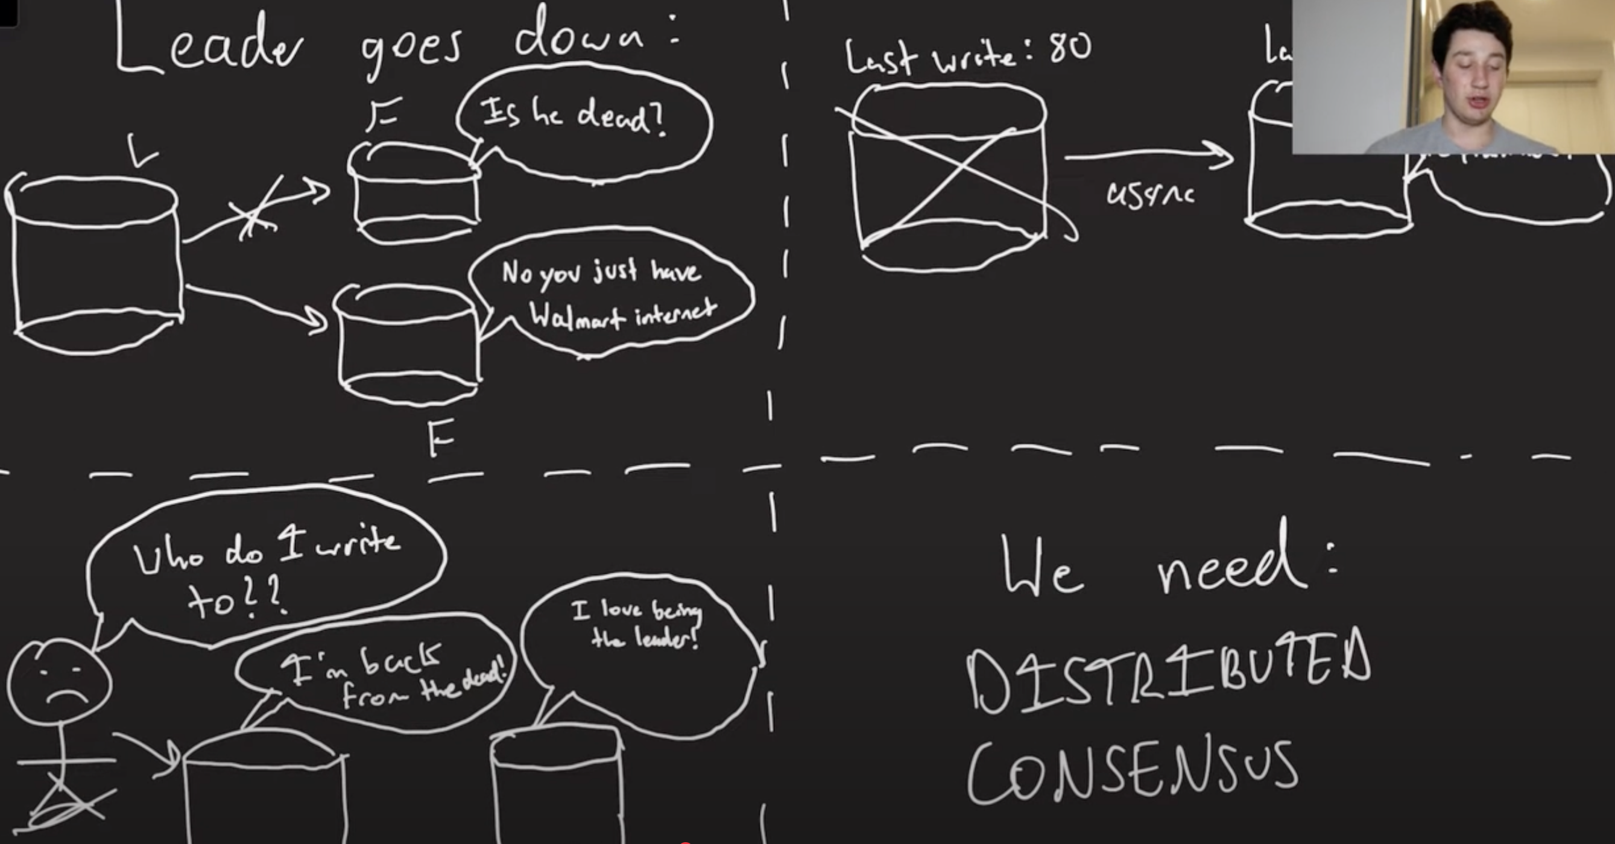

**Main Downsides of Single-Leader Replication:**

* **Single Write Bottleneck:**  
  Only the leader handles writes, limiting write scalability.
* Doesn’t solve apps needing high write throughput—this requires more advanced replication models (to be covered in future videos).

**Conclusion:**

* **Single-leader replication** is great for **simplicity, durability, and read scaling** but has:
  + Difficult **leader failure handling**.
  + No write scalability (limited by the leader).
* Distributed consensus is essential for safe leader failover.
* Future videos will explore **multi-leader** and **leaderless replication** for higher write scalability.

**Video Summary: Multi-Leader Replication Explained (Replication Topologies Series)**

The speaker explains **multi-leader replication**, its **advantages**, **failure risks**, and the **challenge of resolving write conflicts**.

**What is Multi-Leader Replication?**

* A replication topology where **multiple leader nodes** accept **writes**.
* All writes are shared among leaders, and **followers** replicate from the leaders asynchronously.
* This allows:
  + **Higher write throughput** (writes can go to any leader).
  + **Lower latency for distributed users** (users write to nearby leaders).

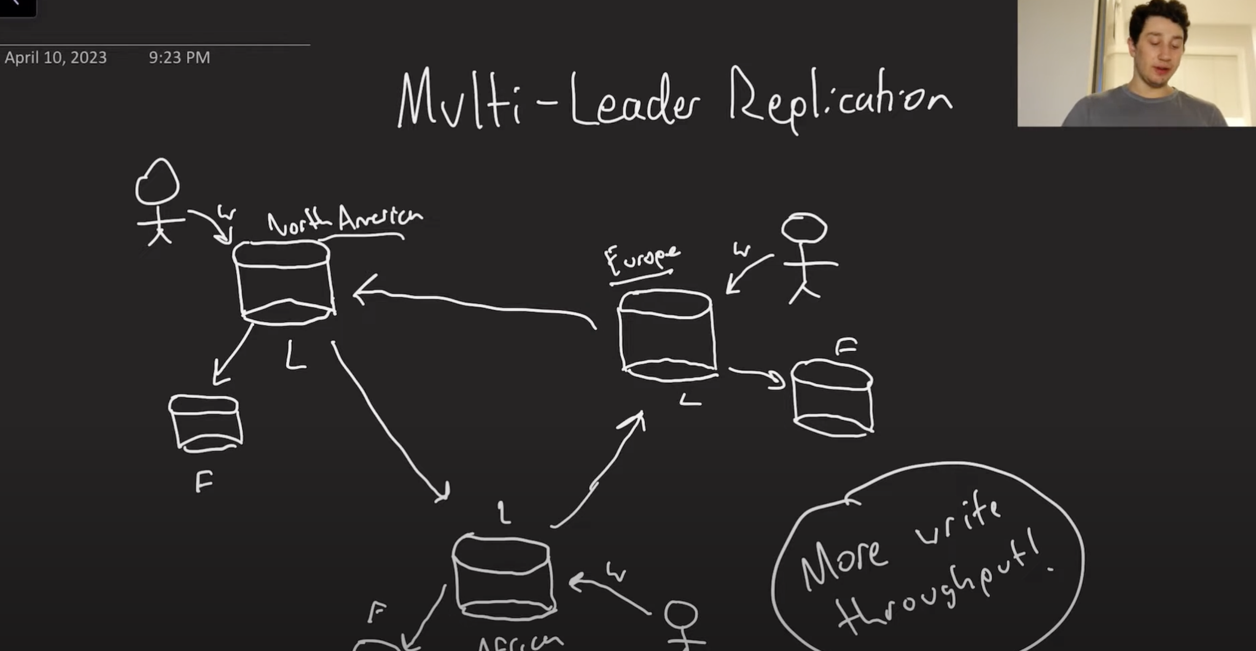

**Common Topologies:**

1. **Circle (Ring) Topology:**
   * Leaders form a loop, passing writes to the next node.
   * **Problem:** Single node failure breaks the chain and halts replication.

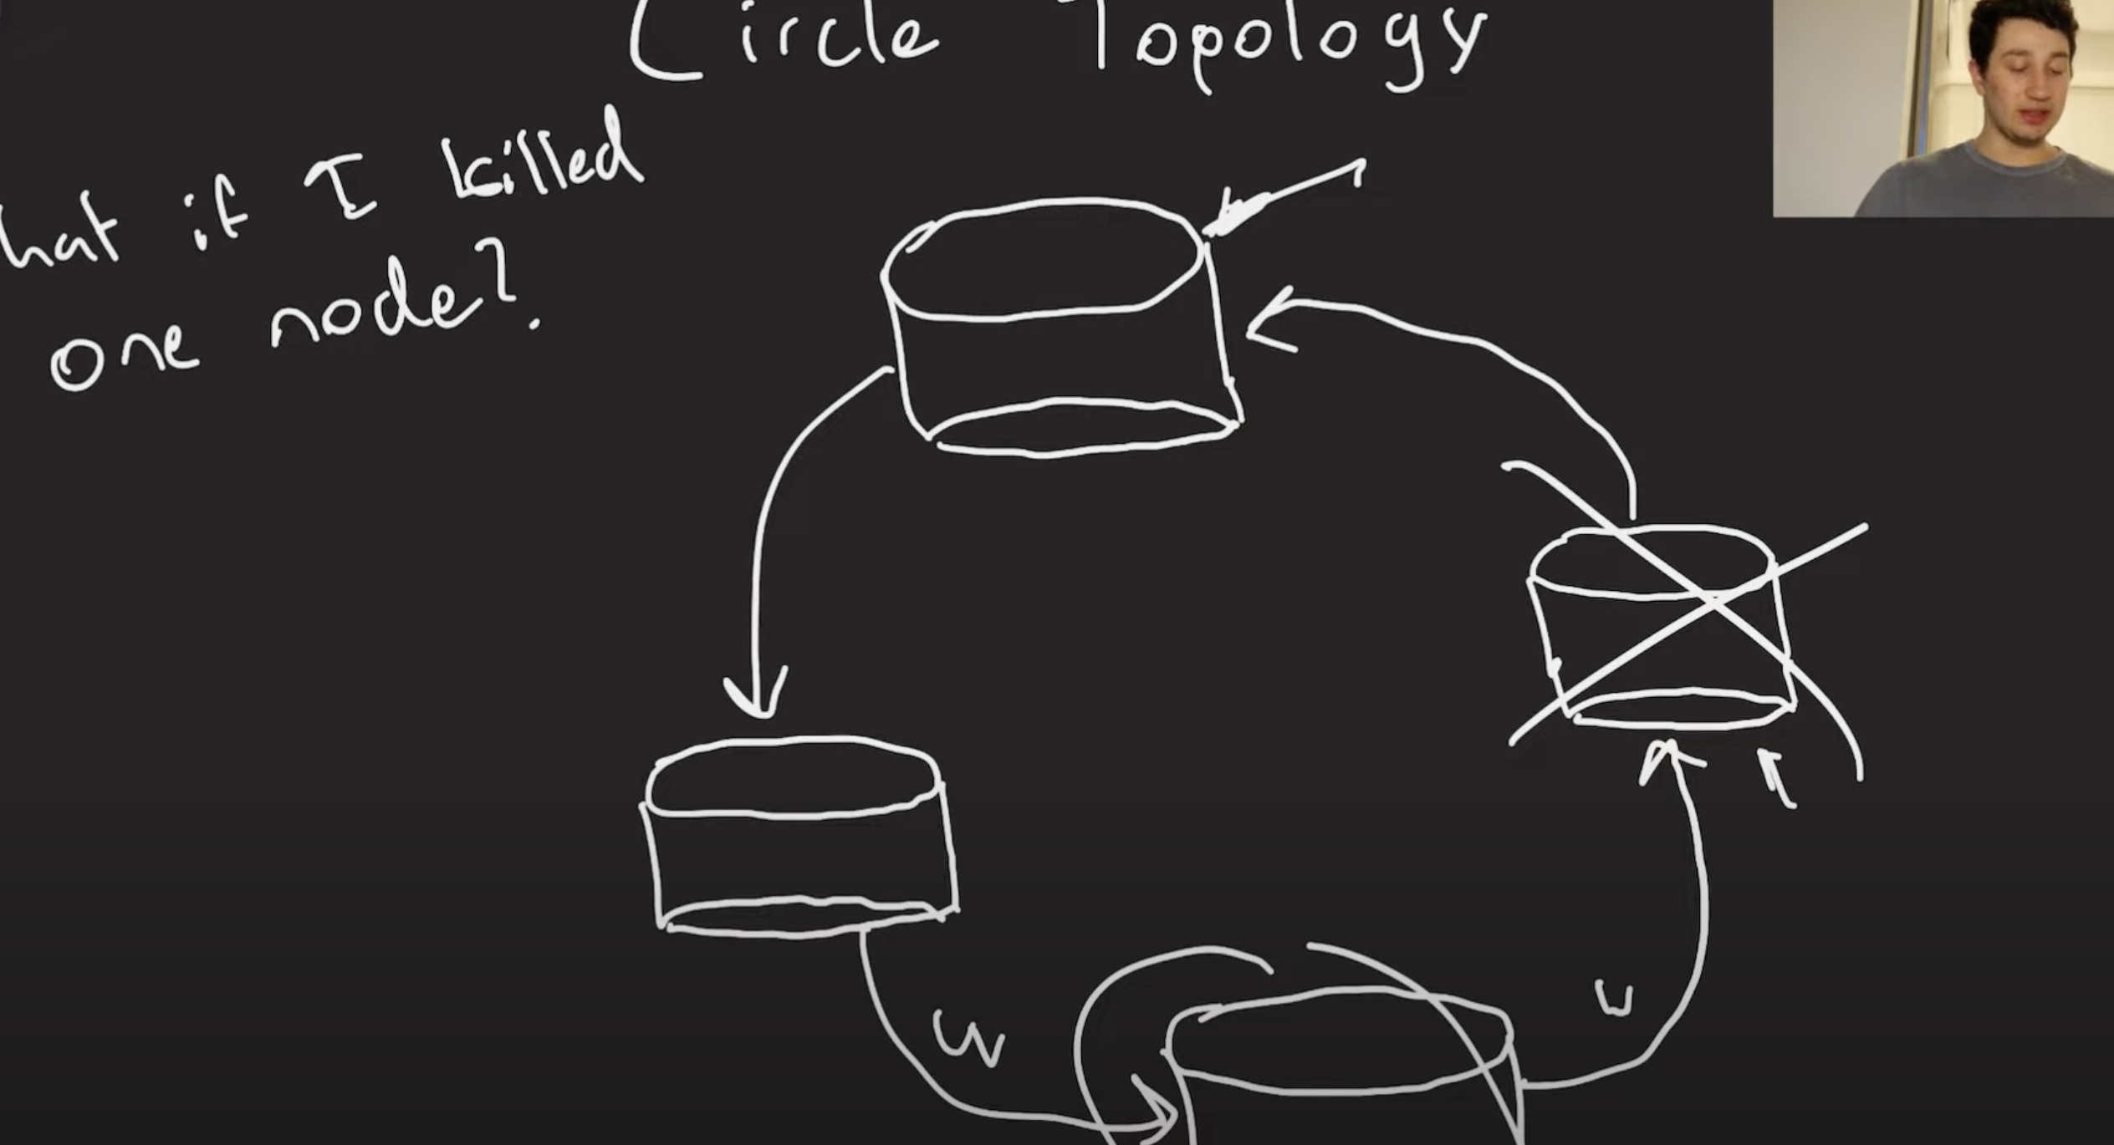

1. **Star Topology:**
   * One central node connects to all others.
   * **Problem:** Central node failure halts the entire system.

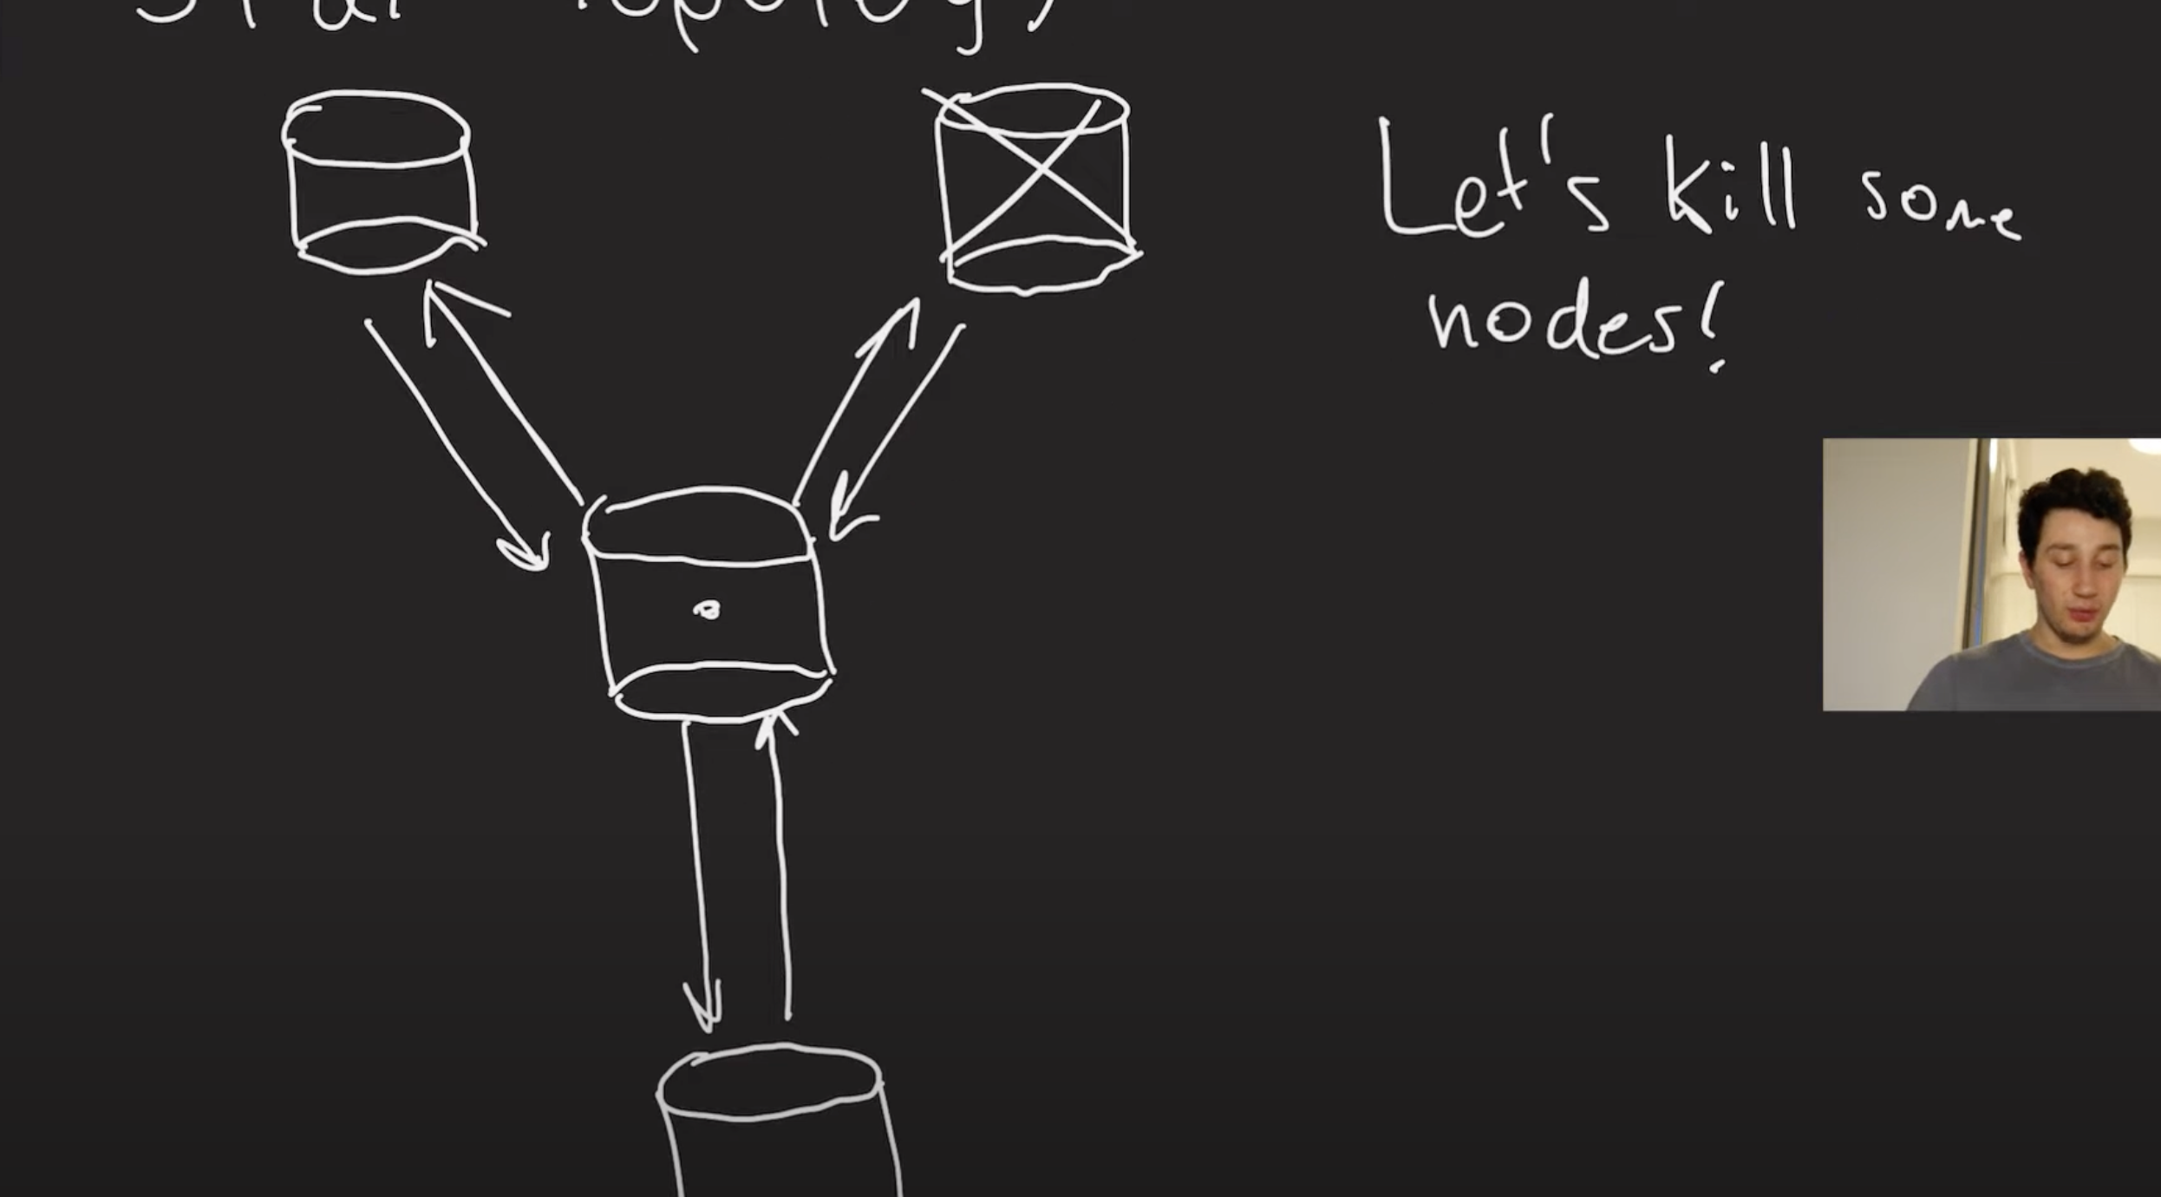

1. **All-to-All Topology:**
   * Every leader communicates with all others.
   * **Benefit:** No single point of failure.
   * **Problem:** Messages (writes) can arrive **out of order**, causing **causality issues**.

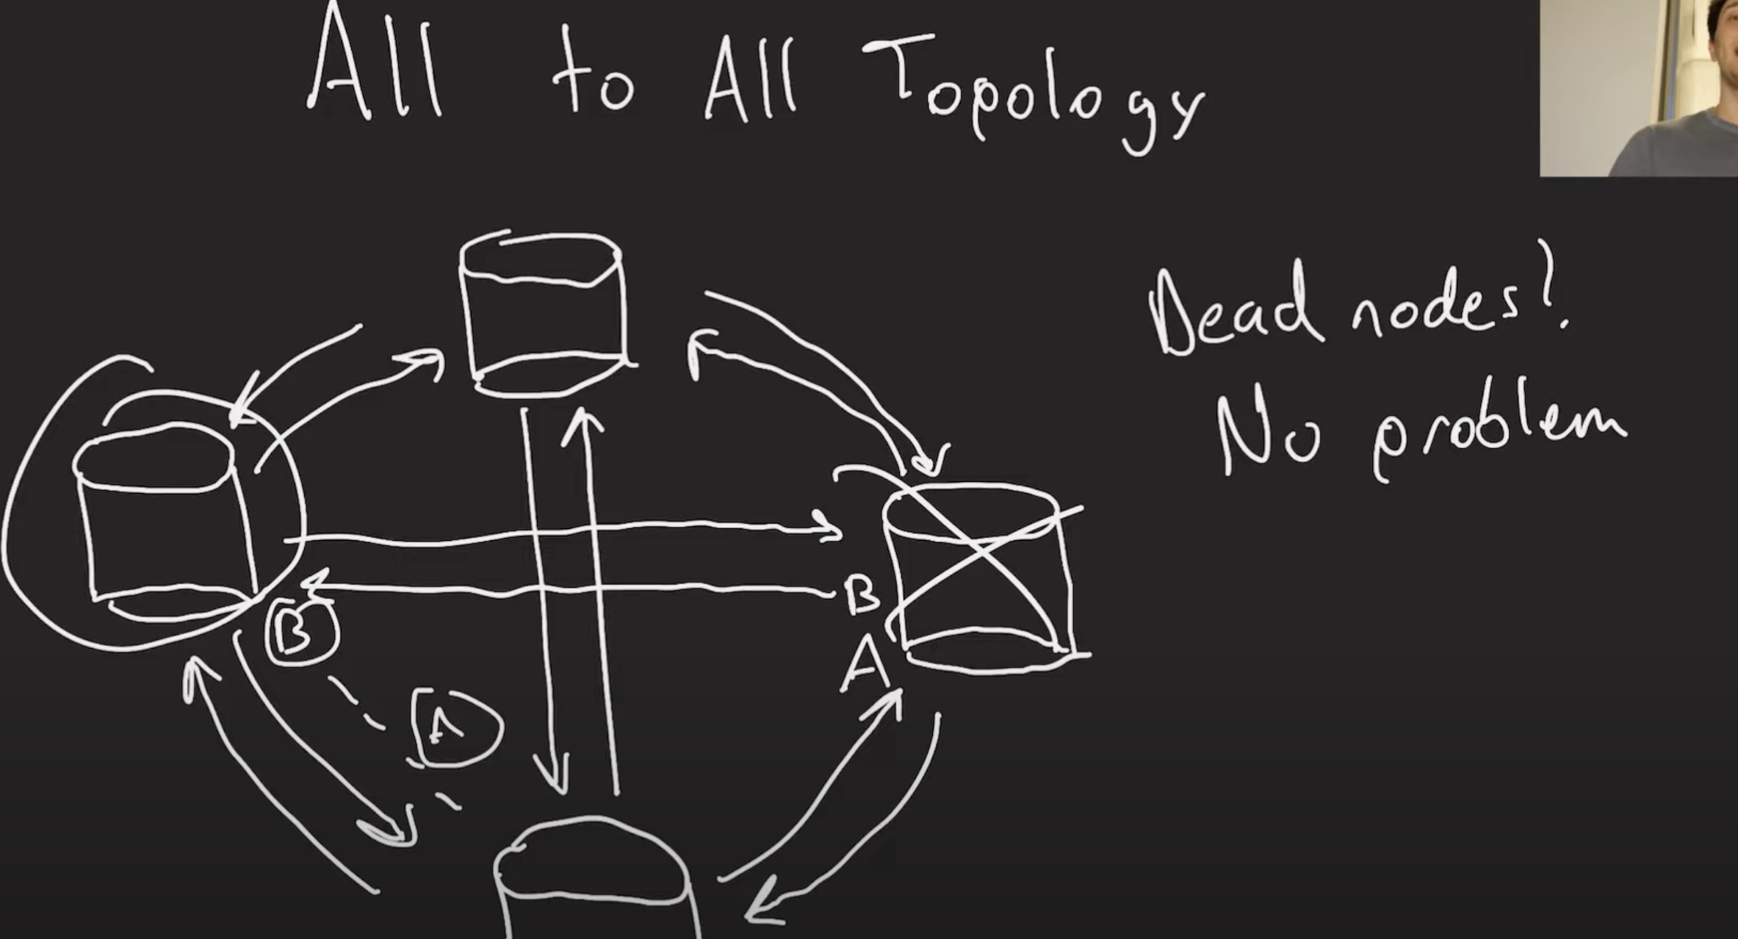

**Key Challenge: Preventing Duplicate or Infinite Message Loops:**

* Solution: Extend the **replication log** to record which nodes have already seen a write.
* This prevents endlessly bouncing writes and ensures each node applies each write **only once**.

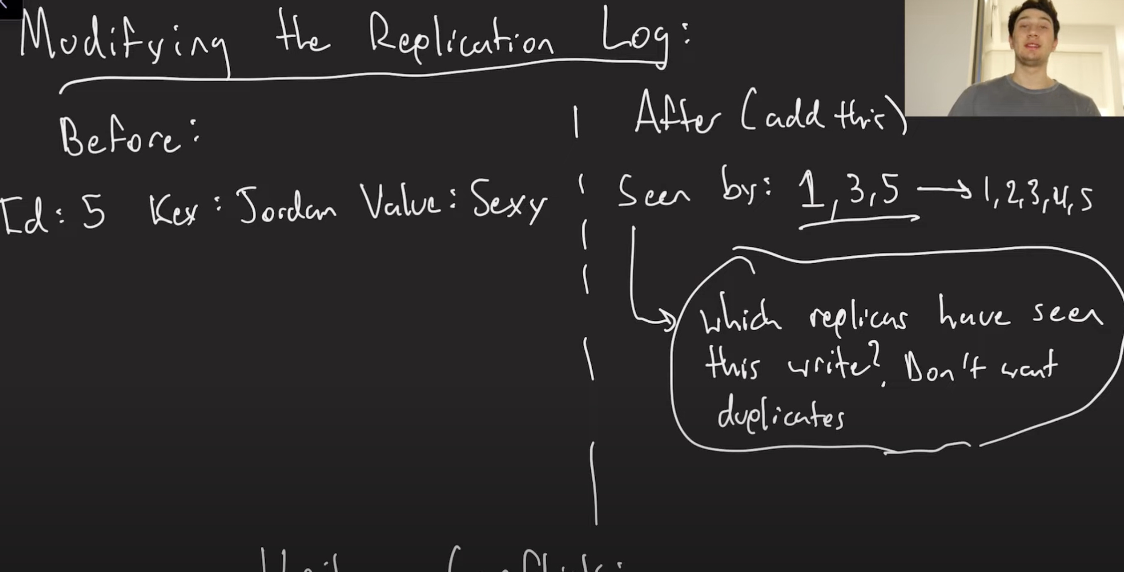

**Major Issue: Write Conflicts (Concurrent Writes to the Same Data):**

* Example:
  + Leader 1 gets write “Jordan is Alpha.”
  + Leader 2 gets write “Jordan is Beta.”
  + Both propagate their conflicting writes to other nodes.

**Ways to Handle Write Conflicts:**

1. **Conflict Avoidance (Partitioning):**
   * Force all writes for the same key to go to the same leader.
   * **Limitation:** Reduces flexibility and increases write latency for some users.

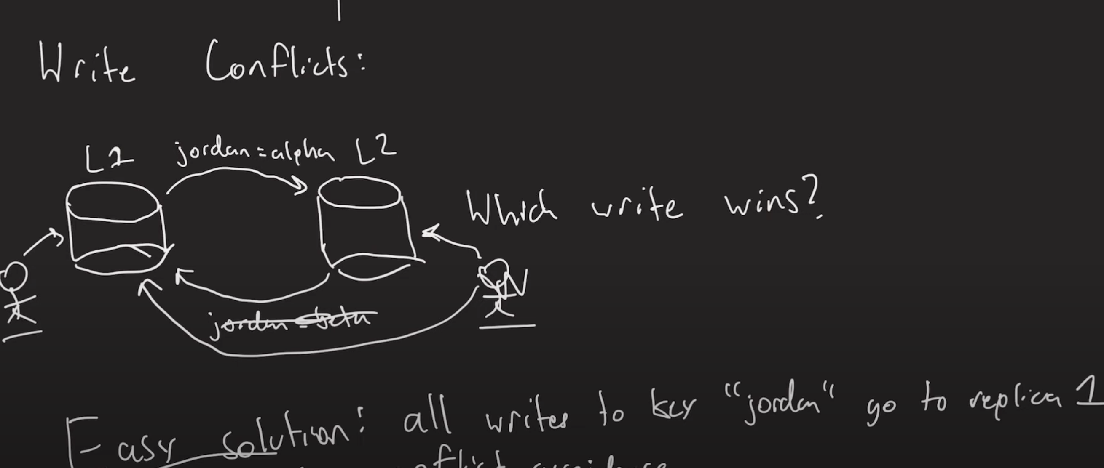

1. **Conflict Resolution via Timestamps (Last-Write-Wins):**
   * Use timestamps to determine which write is newer.
   * **Problems:**
     + Device clocks can be tampered with or inaccurate.
     + Clock drift (quartz clock inaccuracies) leads to inconsistencies.
     + NTP (Network Time Protocol) helps but still suffers from **network delays** and sudden time jumps.
     + Risk of **lost or incorrectly ordered writes** due to unreliable clocks.

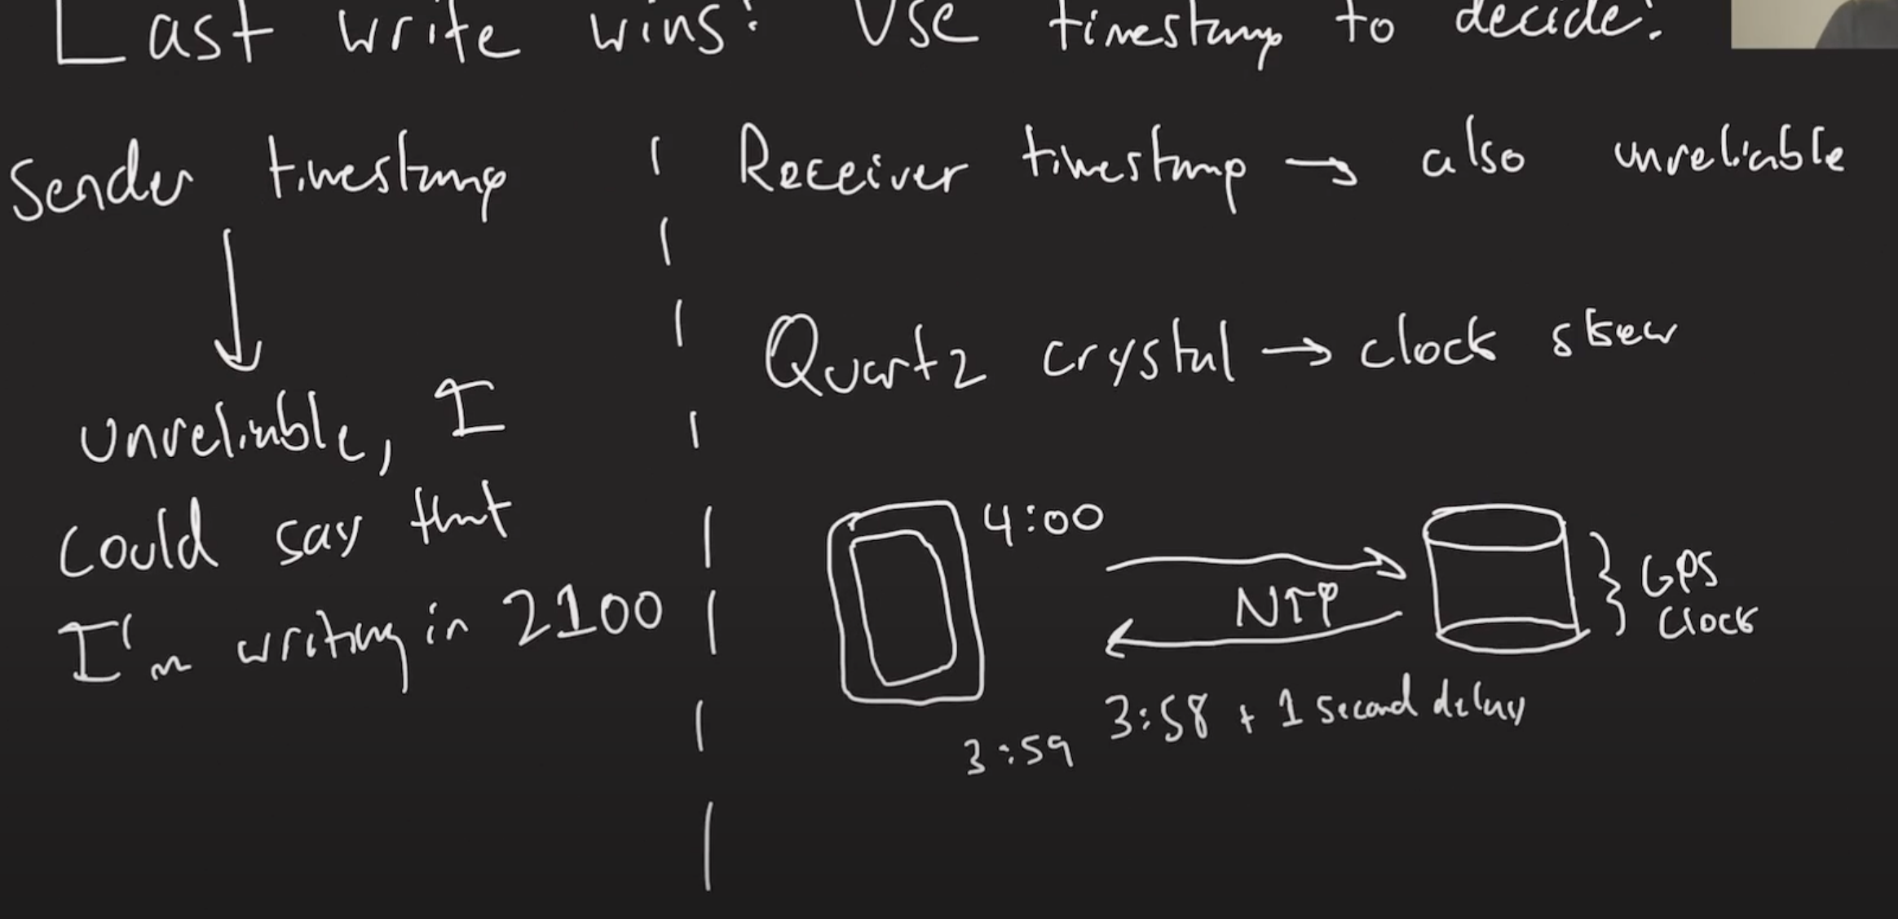

**Key Takeaway:**

* Multi-leader replication provides **higher write throughput** and **geo-distribution benefits**, but introduces complex problems:
  + Write conflicts
  + Data inconsistency
  + Message duplication and causality violations
* No perfect solution exists for write conflicts—it's an **active area of research**.
* Future videos will cover **advanced conflict resolution techniques** and **causal consistency**.

**Video Summary: Detecting Concurrent Writes & Version Vectors (Multi-Leader Replication Series)**

The speaker explains **how to detect concurrent writes** in **multi-leader replication** systems and introduces **version vectors** as a better alternative to unreliable timestamps for resolving write conflicts.

**Background:**

* In **multi-leader replication**, writes can happen at multiple leader nodes simultaneously, causing **write conflicts**.
* Traditional conflict resolution via **timestamps** isn’t reliable due to clock drift, NTP issues, and network delays.

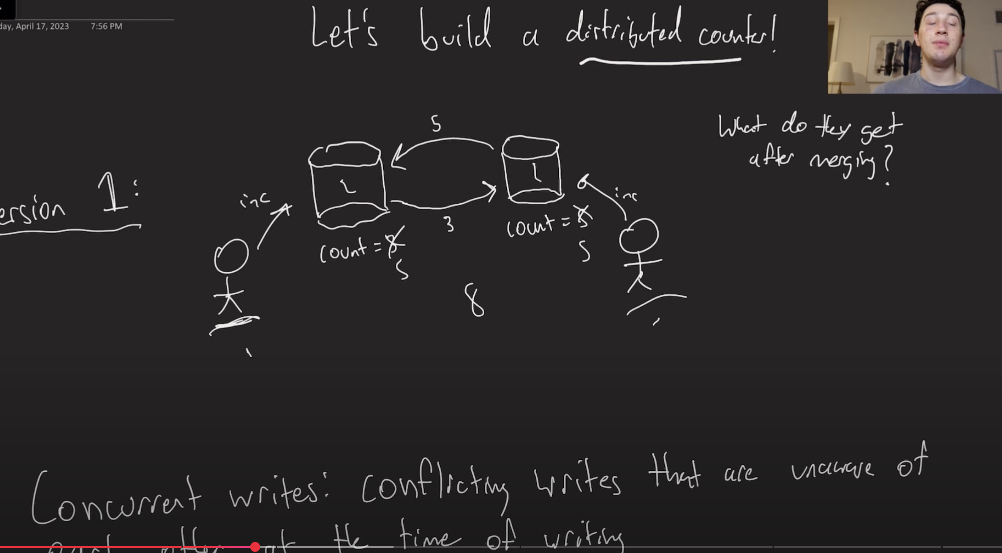

**Solution: Version Vectors (Vector Clocks):**

* Each node tracks the **number of writes** seen from every other node.
* Example:
  + Node A has seen 3 writes from itself, none from B → version vector: (3,0).
  + Node B has seen 5 writes from itself, none from A → (0,5).
* When nodes exchange updates, they **merge** version vectors by summing counts:
  + (3,0) + (0,5) → (3,5).
  + The total count becomes **8** (correct result).

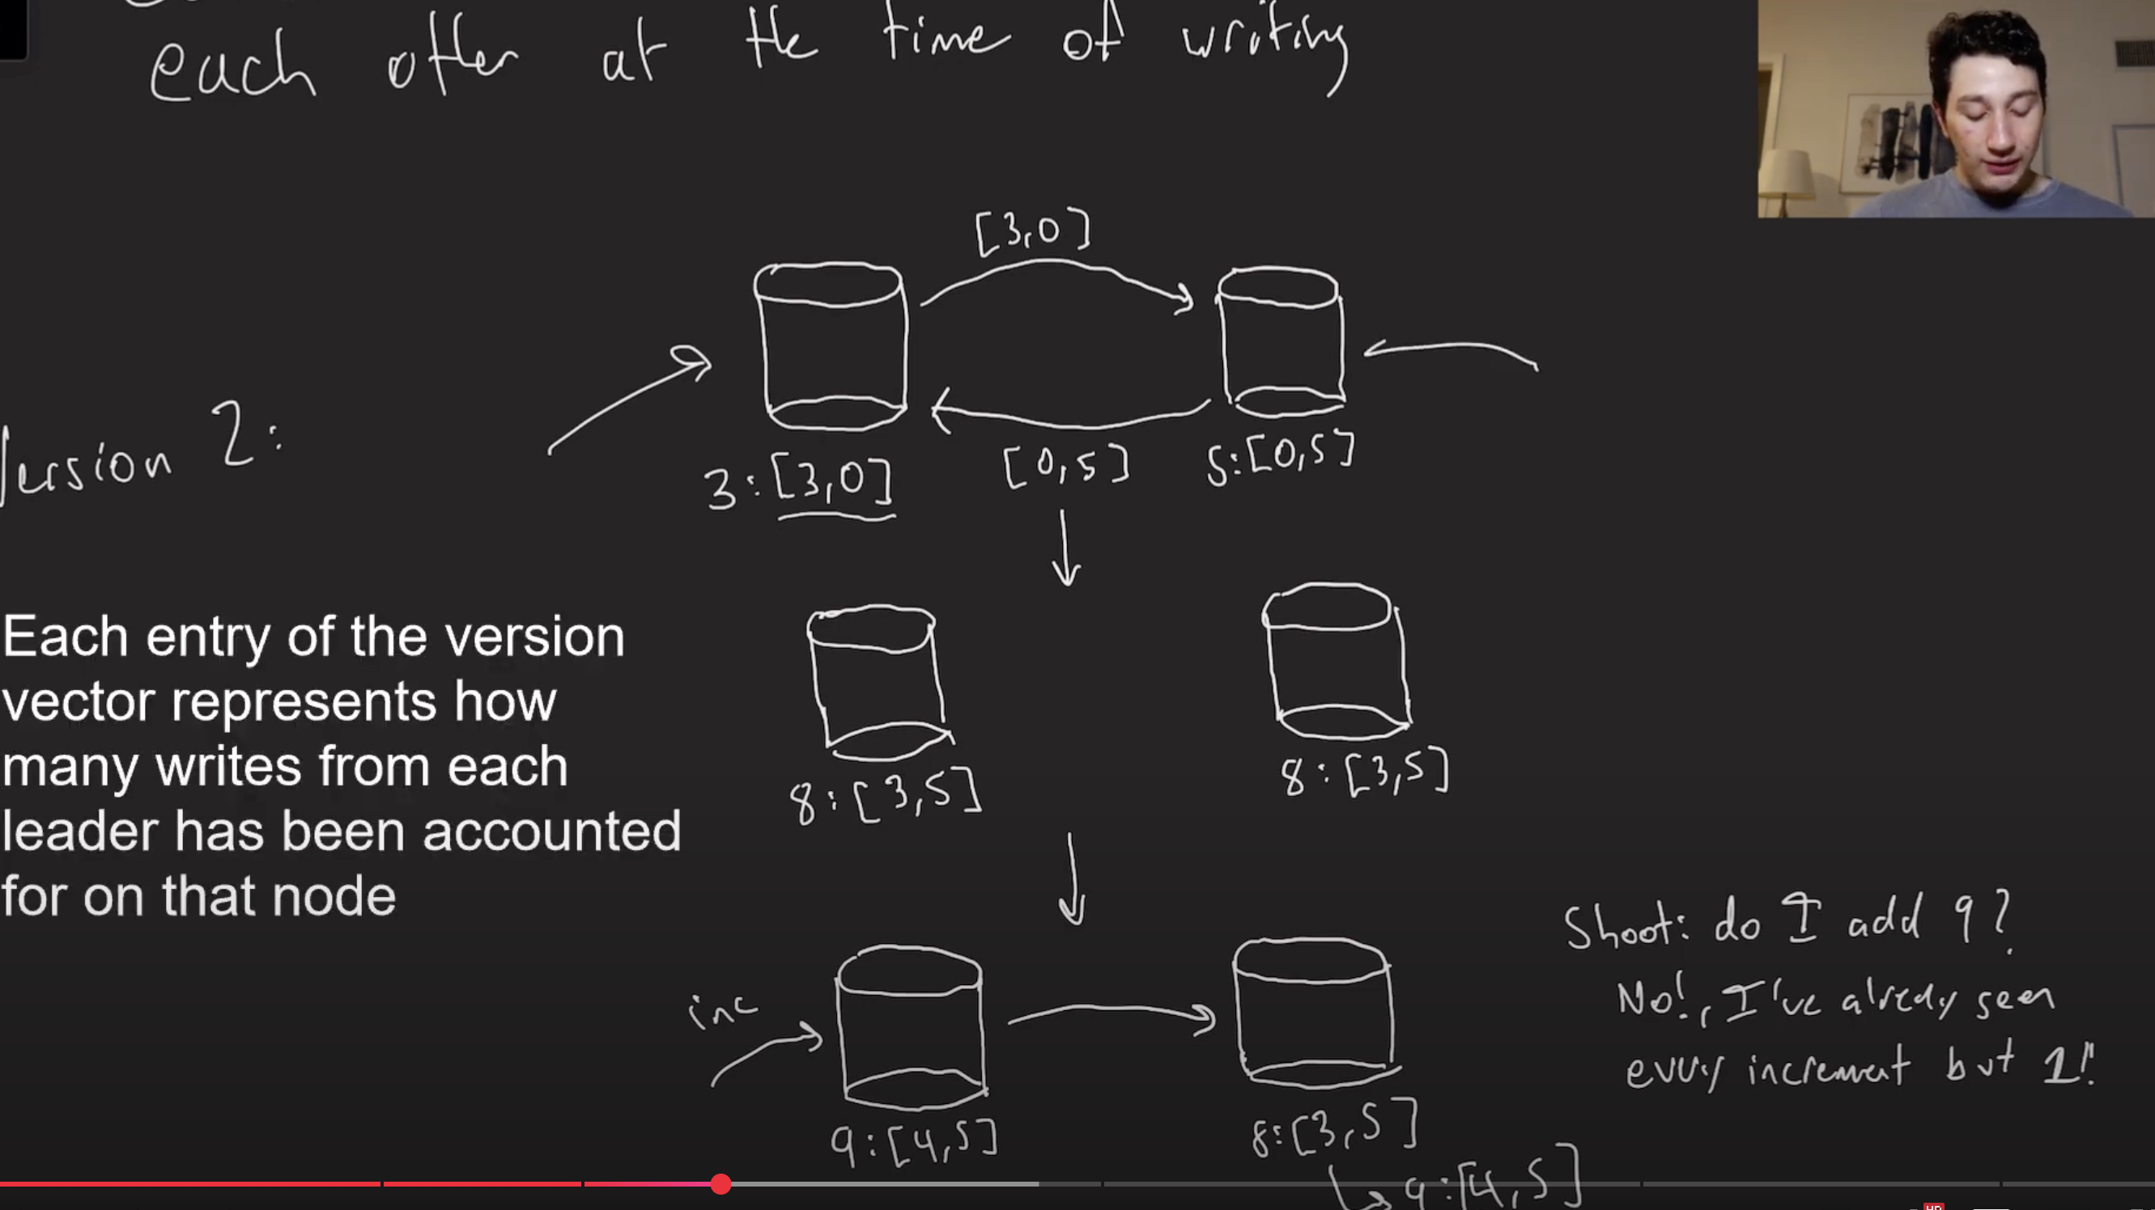

**Key Insight: Detecting Concurrent Writes:**

* **Compare version vectors**:
  + If all entries in vector A ≥ vector B, A happened after B (no conflict).
  + If entries **interleave** (some higher, some lower), the writes are **concurrent**.
* Example:
  + (5,2) vs (4,3) → concurrent, as neither fully dominates the other.

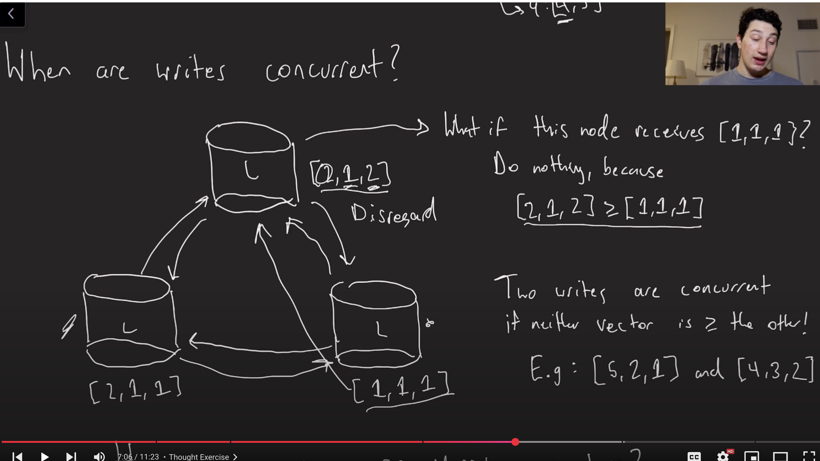

**Conflict Resolution Strategies:**

1. **Storing Siblings (Manual Resolution):**
   * Keep both conflicting versions (siblings) in the DB.
   * Present options to users during reads, letting them manually resolve the conflict.

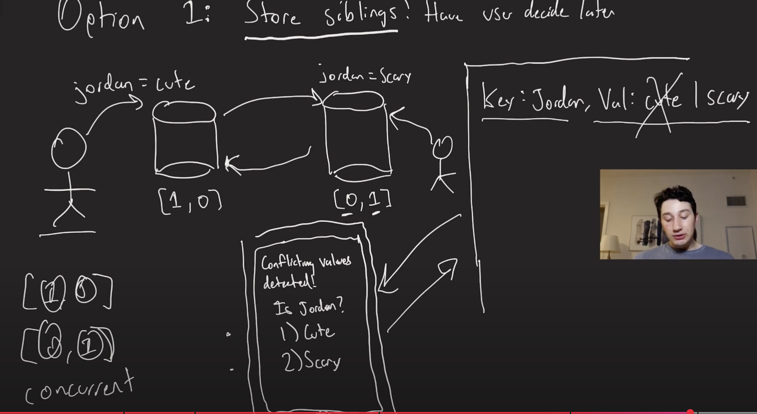

1. **Automatic Resolution via CRDTs (Conflict-Free Replicated Data Types):**
   * Special data structures designed to **merge concurrent writes** automatically without conflicts.
   * Example: Counters (sum version vectors), Sets, etc.
   * CRDTs make certain types of distributed data safe from conflicts by design.
   * More on CRDTs in the next video.

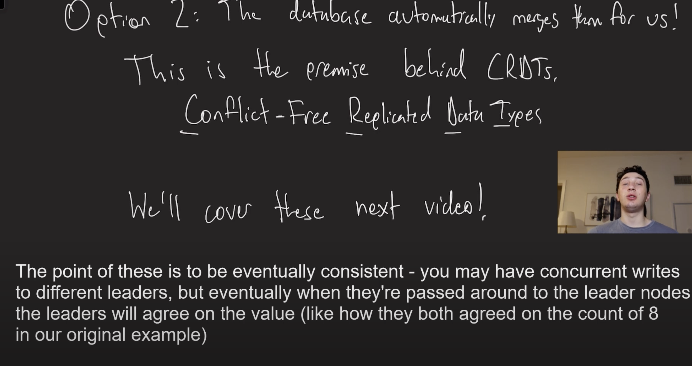

**Main Takeaway:**

* **Version vectors** allow reliable detection of **concurrent writes** without relying on system clocks.
* This technique enables better conflict resolution, either manually or automatically (via CRDTs).
* Next video will dive deeper into CRDTs and then transition to **leaderless replication** topics.

**Video Summary: CRDTs (Conflict-Free Replicated Data Types) Explained (Multi-Leader Replication Series)**

The speaker explains **CRDTs (Conflict-Free Replicated Data Types)**—a way to automatically resolve **write conflicts** in **multi-leader replication** systems without user intervention.

**Background:**

* In multi-leader replication, **write conflicts** are inevitable.
* Traditional solutions:
  1. **Last-Write-Wins (LWW):** Relies on timestamps (unreliable in distributed systems).
  2. **Version Vectors + Siblings:** Detect conflicts and store all conflicting versions for manual merging.
  3. **CRDTs:** Automatically resolve conflicts without manual intervention.

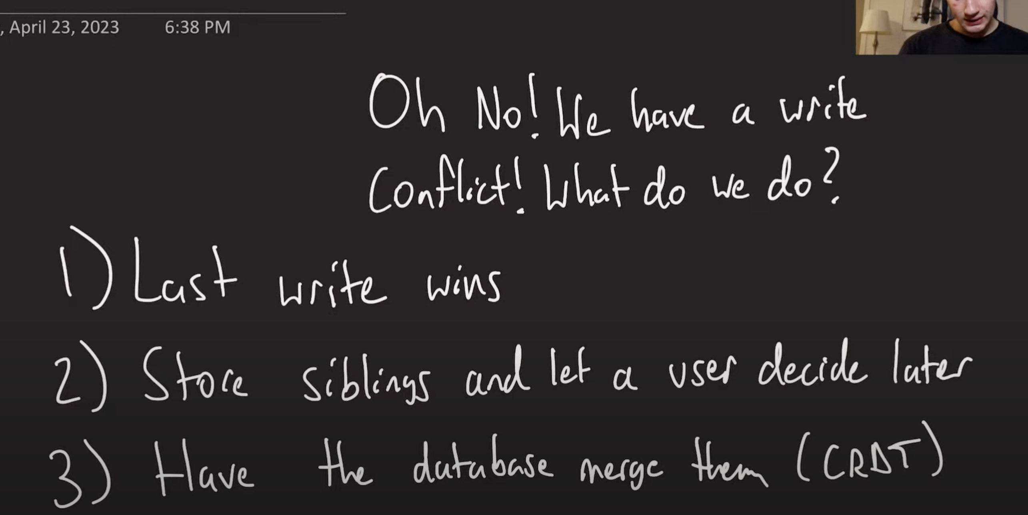

**CRDT Concept:**

* Example: Two users adding items to a **shared shopping list** from different nodes.
* Goal: Automatically merge changes so all nodes eventually agree on the full list (e.g., ham, eggs, milk, cookies).

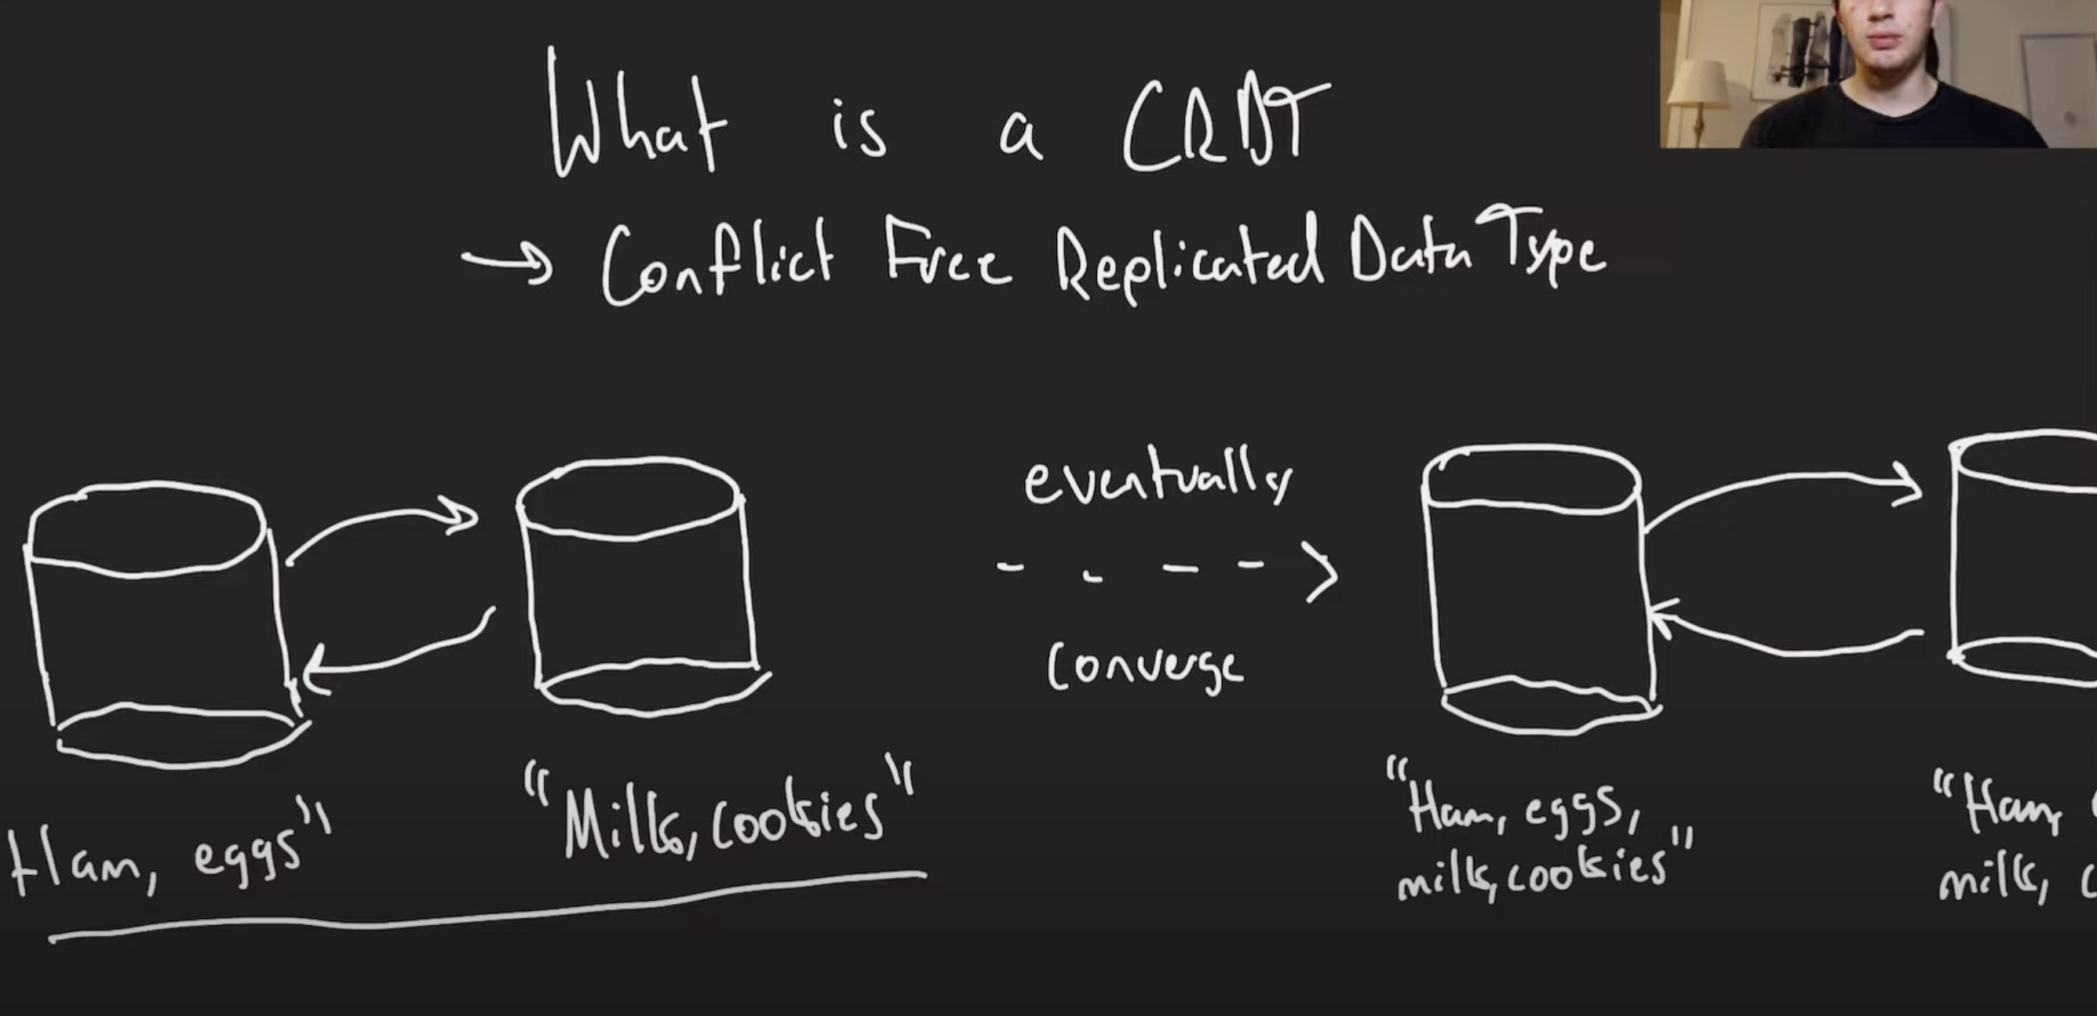

**CRDT Types:**

1. **Operational CRDTs (Op-based):**
   * Only send **operations** (like "increment" or "add") over the network.
   * Lightweight (small messages).
   * Requires **causal consistency** and reliable message delivery (no lost or duplicated messages).
   * Example issue: Removing an item that was never added due to missing messages.

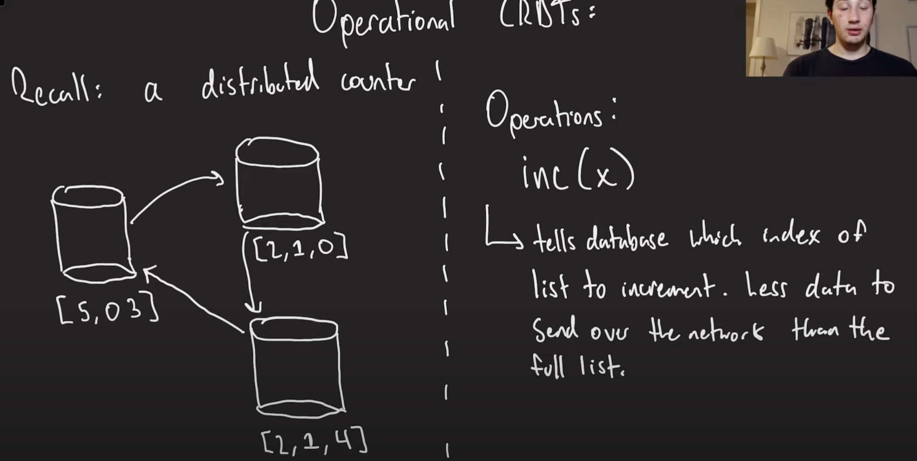

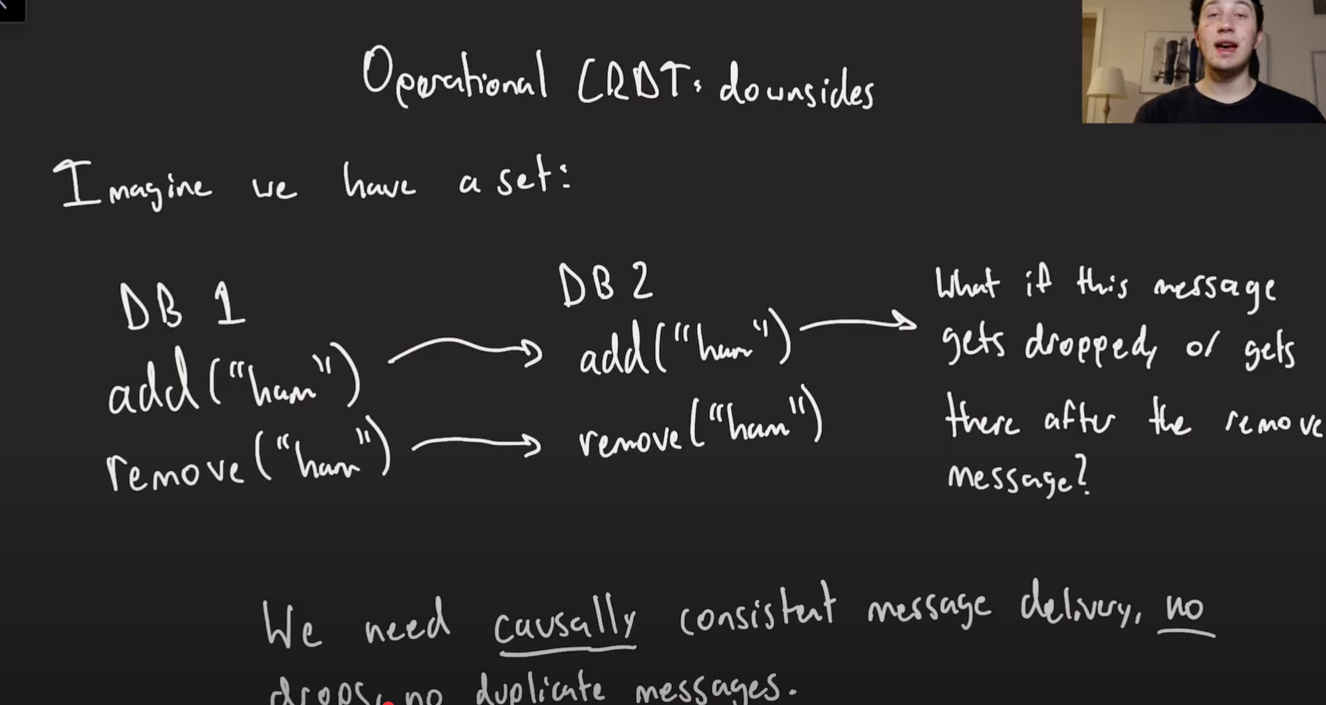

1. **State-based CRDTs:**
   * Send the **entire state** of the data structure (like a full counter or set).
   * Merge function must be:
     + **Commutative:** Order doesn’t matter.
     + **Associative:** Grouping doesn’t matter.
     + **Idempotent:** Duplicate messages don’t affect correctness.
   * Often used with **gossip protocols** to efficiently spread updates across nodes.
   * Downsides: Can be bandwidth-heavy for large states; slower convergence in large networks.

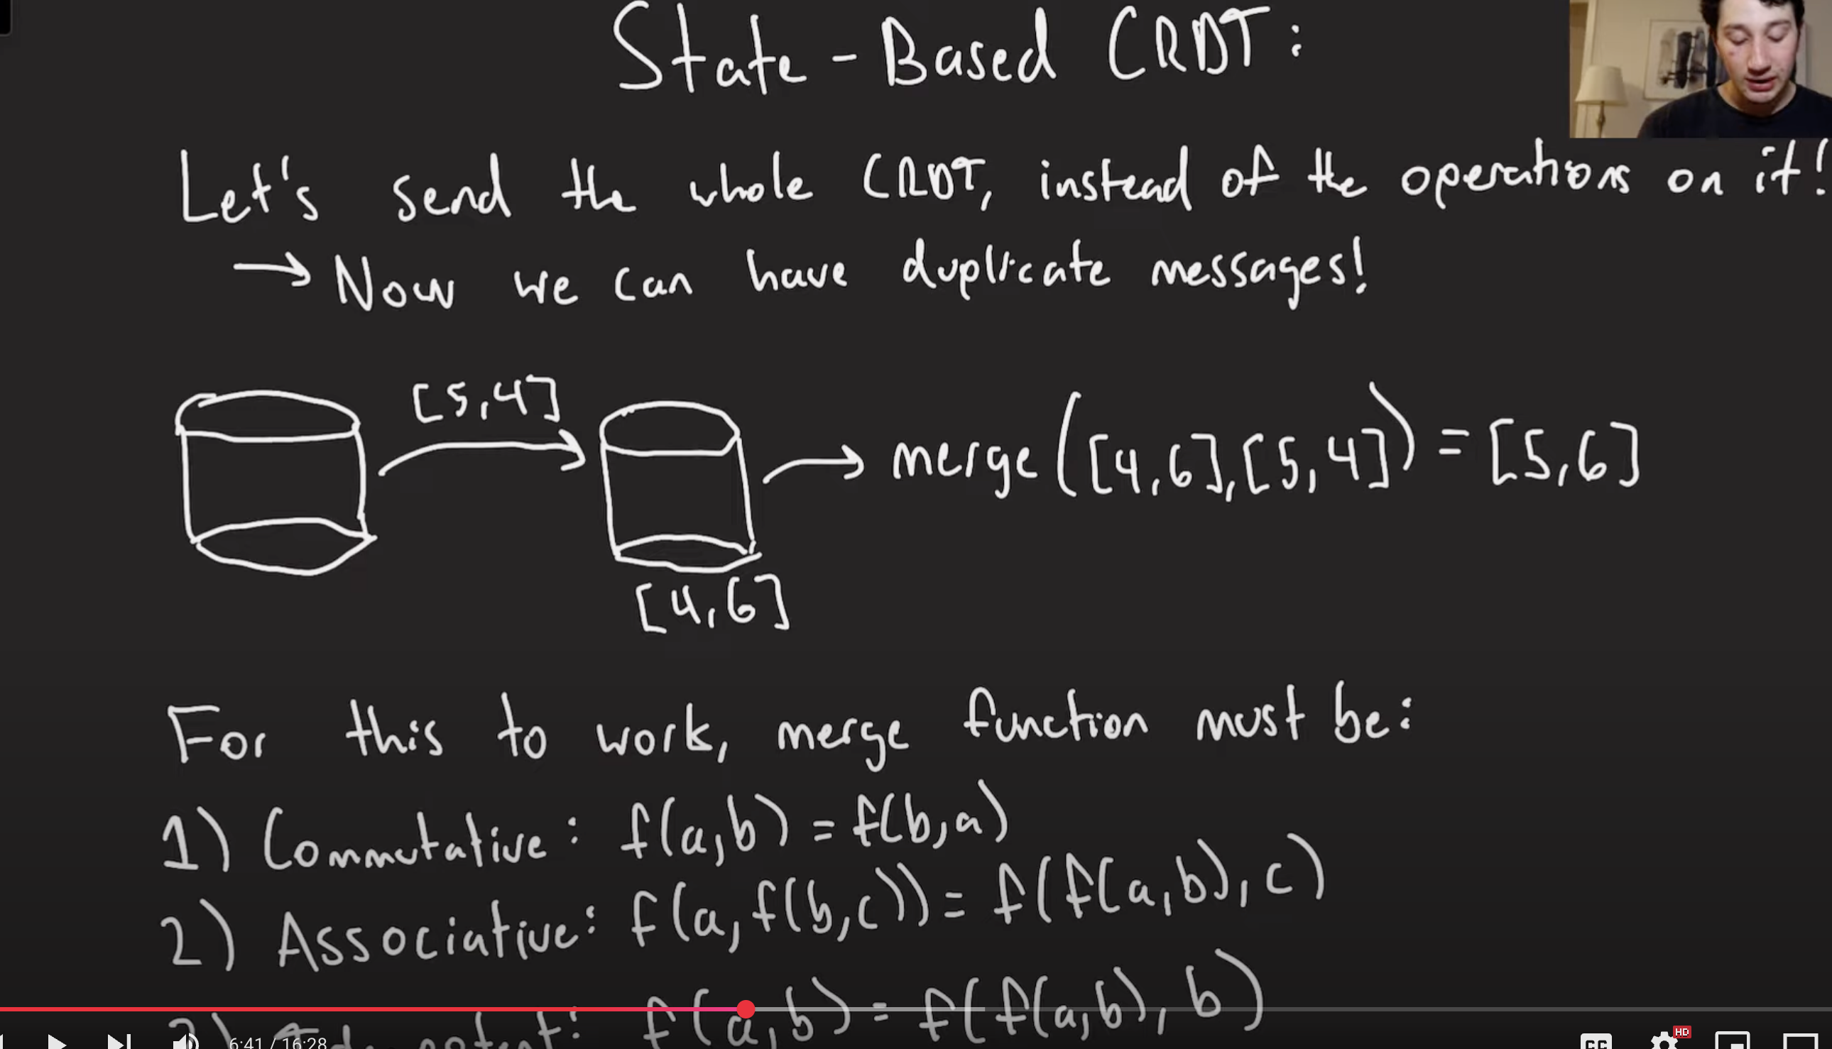

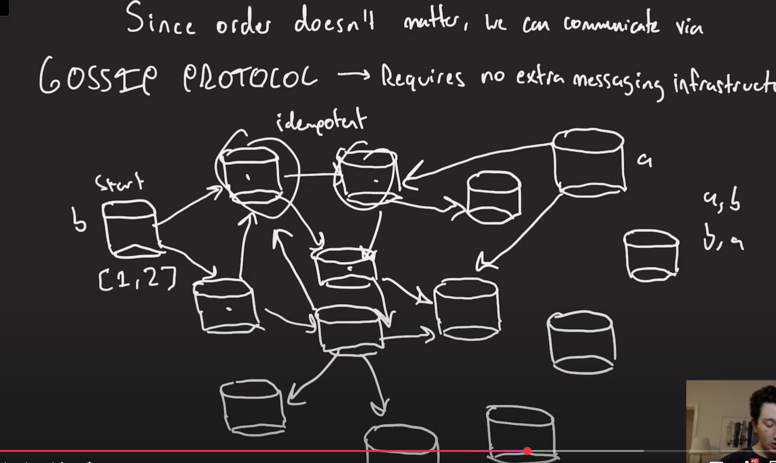

**Common CRDT Data Structures:**

1. **Counters:**
   * Simple sum of increments from all nodes.
2. **Decreasable Counters:**
   * Track both increments and decrements from each node.

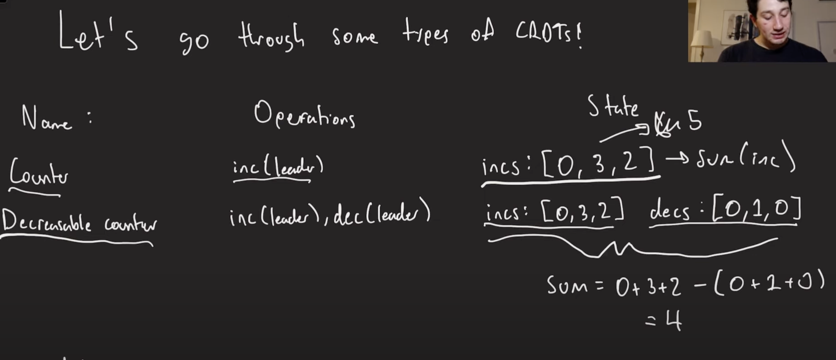

1. **Sets:**
   * Keep track of:
     + Elements **added**.
     + Elements **removed**.
   * Merging: Union of add-sets and remove-sets.
   * Limitation: Elements can’t be re-added once removed unless using **unique tags** per addition.
     + Unique tags allow re-adding by distinguishing different additions of the same element.

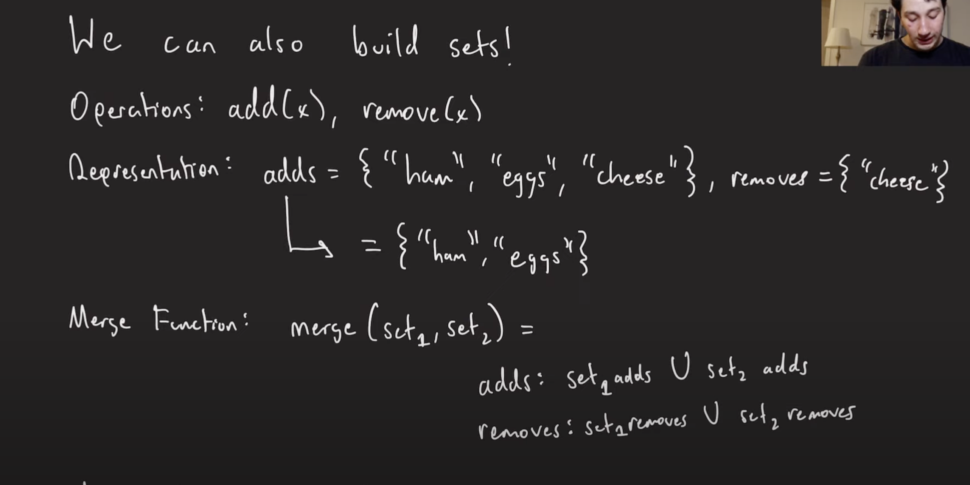

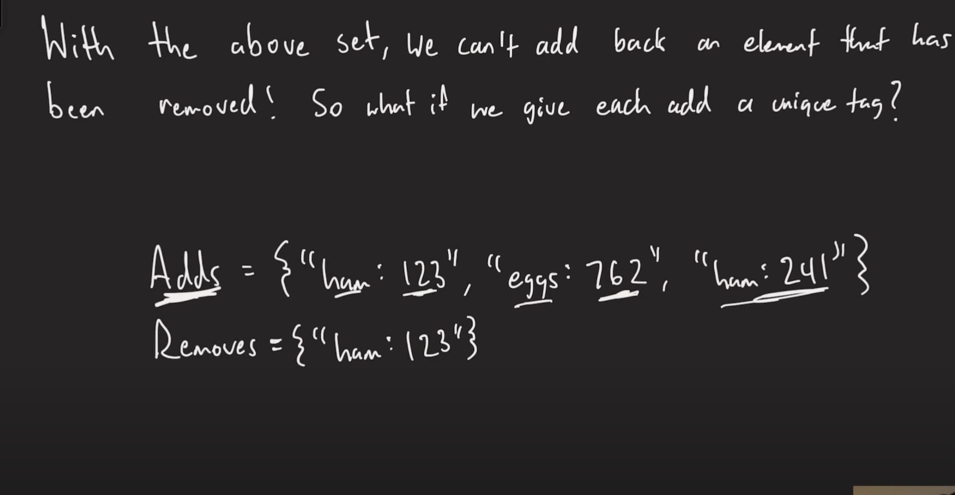

**Advanced Topic (Teaser for Future Video):**

* **Sequence CRDTs** (ordered lists)
  + Much harder to implement due to element ordering.
  + Used in **real-time collaborative tools** (e.g., Google Docs, VS Code Live Share).
  + Will be covered in-depth in a future video.

**Key Takeaways:**

* CRDTs are powerful tools for automatically resolving conflicts in distributed systems.
* State-based CRDTs are simpler but heavier; Op-based CRDTs are lightweight but need strict guarantees.
* Useful for counters, sets, and more advanced data types.
* Real-world use cases include databases like **Riak** and **Redis** (enterprise versions).

**Video Summary: Leaderless Replication Explained (Replication Series Continuation)**

The speaker introduces **leaderless replication**, explaining how it works, where it’s used, and key mechanisms for maintaining consistency across nodes.

**What is Leaderless Replication?**

* Instead of sending writes to a single leader, **writes and reads happen on multiple nodes simultaneously**.
* Common in distributed databases like:
  + **Cassandra**
  + **Riak**
  + *Not* used by DynamoDB (despite common misconceptions).

**How It Works:**

1. A client (example: Kate Upton) writes data (e.g., "Jordan is cute") to multiple nodes.
2. Each node keeps a **version number** for each key (e.g., version 21 for the updated value).
3. When reading, the client compares versions across nodes:
   * Picks the latest version based on the version number.
   * Can perform a **read repair**—updates stale nodes with the latest data during reads.

**Two Methods for Data Repair:**

1. **Read Repair:**  
   During a read, the client updates stale nodes with the newest version it has seen.
2. **Anti-Entropy (Background Sync):**
   * Periodic process where nodes sync missing updates with each other.
   * Challenge: Nodes don’t want to resend every write unnecessarily.
   * Solution: **Merkle Trees** (Hash Trees) efficiently identify differences between nodes.

**How Merkle Trees Work (For Anti-Entropy):**

1. Hash each row in the database.
2. Combine hashes in pairs up a binary tree structure to produce a **root hash**.
3. Compare root hashes between nodes:
   * If root hashes differ, drill down to child nodes to locate differences.
4. Efficiently detects differing rows in **O(log n)** time (much faster than full table scans).
5. Only differing rows need to be exchanged, reducing network load.

**Key Takeaway:**

* Leaderless replication allows higher availability and flexibility but introduces new challenges for consistency.
* Tools like **read repair** and **anti-entropy with Merkle trees** help reconcile differences between nodes.

**Next Video Teaser:**

* Will cover **how to guarantee that a read will definitely see specific writes** without waiting for background repairs like anti-entropy—a crucial consistency mechanism in leaderless systems.

**Video Summary: Quorums in Leaderless Replication (Replication Series Continuation)**

The speaker continues the discussion on **leaderless replication**, focusing on **quorums**—a method to improve read consistency without waiting for read repair or anti-entropy.

**Recap of Leaderless Replication:**

* Clients can write to **multiple nodes** and read from multiple nodes.
* Data syncs via:
  + **Read repair** (during reads).
  + **Anti-entropy** (background syncing using Merkle trees).

**New Concept: Quorums (Quorum Reads & Writes):**

* Definitions:
  + **n:** Total number of nodes in the cluster.
  + **W:** Number of nodes a client must successfully write to.
  + **R:** Number of nodes a client reads from.
* **Quorum Condition:**  
  If **W + R > n**, then there is guaranteed overlap between nodes written to and nodes read from, ensuring that at least one node has the latest data.

**Key Example:**

* 5-node cluster (**n = 5**).
* Writer writes to 3 nodes (**W = 3**).
* Reader reads from 3 nodes (**R = 3**).
* Guarantees that at least one node read has the latest write.

**Important Insight:**

Quorums **seem** to provide strong consistency—but **don’t** guarantee it in all cases.

**Why Quorums Are Not Fully Strongly Consistent:**

1. **Race Conditions:**
   * Multiple concurrent writers can cause nodes to disagree on which write is latest due to differing arrival orders.
   * Readers may get conflicting results even if reading at the same time.
2. **Failed Writes:**
   * A write might partially succeed (written to only some nodes).
   * Readers may see inconsistent or "invalid" values because incomplete writes aren’t rolled back automatically.
3. **Sloppy Quorums & Hinted Handoff:**
   * Writes may get routed to different clusters (e.g., in another region) during outages.
   * Once the original cluster recovers, a read from it won’t see those writes until a **hinted handoff** syncs the data back.
   * Creates temporary inconsistency even if Quorum conditions are met.

**Conclusion:**

* Quorums greatly improve **read consistency** in leaderless replication but **don’t provide strict strong consistency**.
* They’re suitable for systems where occasional inconsistency is acceptable (e.g., social media apps).
* Not suitable for systems requiring **strict consistency** (e.g., financial data).
* Stronger guarantees require **distributed consensus protocols**—to be covered in future videos.

**Video Summary: Replication in Databases (Quick Recap)**

**In this fast-paced, humorous video, the speaker summarizes replication in databases, covering the major types, their trade-offs, and key concepts in under 10 minutes.**

**Purpose of Replication:**

* **Durability: Survive data center failures by having data on multiple nodes.**
* **Higher Throughput: Distribute writes across nodes to handle more requests.**
* **Geographic Performance: Serve users from nearby data centers for faster access.**

**1. Single-Leader Replication:**

* **How it Works: One *master* node handles all writes; other *followers* replicate data and serve reads.**
* **Pros:**
  + **No write conflicts (only one node handles writes).**
* **Cons:**
  + **Single Point of Failure: If leader dies, system is vulnerable; leader election introduces risks like *split-brain*.**
  + **Low Write Throughput: Bottlenecked by one leader node.**
* **Mostly eventually consistent (unless synchronous replication, which is slow).**

**2. Multi-Leader Replication:**

* **How it Works: Multiple leader nodes; each can handle reads and writes, replicating changes among themselves.**
* **Pros:**
  + **High write throughput (users write to local data centers).**
* **Cons:**
  + **Risk of write conflicts (simultaneous writes to different nodes).**
  + **Solutions:**
    - **Version Vectors: Detect concurrent writes.**
    - **Store Siblings: Keep both versions, resolve later.**
    - **CRDTs: Automatically merge some types of data (like counters or sets).**

**3. Leaderless Replication (Quorum-Based):**

* **How it Works: Clients write to and read from multiple nodes simultaneously (no designated leader).**
* **Key Concept: Quorum Reads & Writes**
  + **Example: 3 nodes (n=3), write to 2 nodes (W=2), read from 2 nodes (R=2).**
  + **If W + R > n, ensures at least 1 overlapping node, allowing clients to pick the newest version via version numbers.**
* **Background Mechanisms:**
  + **Read Repair: Fix outdated nodes during reads.**
  + **Anti-Entropy: Periodic background syncing using Merkle Trees.**
* **Pros:**
  + **High write throughput (better than single-leader, though often below multi-leader).**
  + **Configurable consistency via quorum thresholds.**
* **Cons:**
  + **Low read throughput (multiple node reads can be slower).**
  + **Still prone to write conflicts and inconsistencies in some cases:**
    - **Sloppy quorums.**
    - **Partial writes that fail to meet quorum thresholds.**

**Conclusion:**

* **Each replication type has trade-offs between:**
  + **Throughput vs Consistency**
  + **Simplicity vs Flexibility**
* **Leaderless & multi-leader setups are better for high-traffic, geographically distributed systems.**
* **Single-leader setups are simpler but limited in scalability and resilience.**

**Final Notes:**

* **This video is a fast recap of previous, more detailed videos on each replication type.**
* **If you need deeper explanations, watch the corresponding videos.**

**Video Summary: Comprehensive Database Systems Design Guide**

In this long-awaited video, the speaker provides an in-depth, all-in-one **guide to databases** for systems design interviews. The video covers everything from index types to replication strategies and a broad range of databases with their use cases.

**1. Indexing Structures (Recap):**

* **LSM Trees + SSTables:**
  + **Writes:** Fast (in-memory, flushed to disk later).
  + **Reads:** Slower (may check multiple SSTables); uses Bloom filters & compaction for optimization.
  + Best for **write-heavy workloads**.
* **B-Trees:**
  + **Reads:** Fast (direct lookup via tree on disk).
  + **Writes:** Slower (direct disk writes).
  + Best for **read-heavy workloads**.

**2. Replication Models (Recap):**

* **Single-Leader Replication:** One master node handles writes; avoids write conflicts but has lower write throughput.
* **Multi-Leader Replication:** Multiple leaders; higher write throughput, but risk of write conflicts.
* **Leaderless Replication:** Any node can handle writes/reads; highest flexibility but requires quorum mechanisms and conflict resolution.

**3. Detailed Database Comparisons:**

**SQL Databases (MySQL, Postgres, etc.):**

* Data Model: Relational, normalized (joins between tables).
* Strength: ACID guarantees (strong transactions & correctness).
* Index Type: B-Trees.
* Best For: Systems needing strict correctness & transactions (e.g., banking, job scheduling).

**MongoDB (Document Store):**

* Data Model: Document-based (nested, denormalized JSON-like structures).
* Index Type: B-Trees; supports transactions.
* Strength: Flexible schema; good data locality.
* Best For: Apps needing flexible, semi-structured data but still prefer traditional indexing.

**Cassandra (Wide-Column Store):**

* Data Model: Wide-column store; highly flexible schema.
* Replication: Multi-leader or leaderless with configurable quorum.
* Conflict Resolution: Last-Write-Wins (can cause data loss).
* Index Type: LSM Trees (fast writes, slower reads).
* Best For: High write throughput with eventual consistency (e.g., chat apps, logs).

**Riak (Key-Value Store with CRDTs):**

* Similar to Cassandra but uses **CRDTs** for better conflict resolution.
* Strength: Can safely merge conflicting writes for complex data types (sets, counters).
* Best For: Systems needing eventual consistency with more advanced conflict resolution.

**Apache HBase (Wide-Column Store):**

* Built on HDFS (Hadoop); uses **single-leader replication**.
* Index Type: LSM Trees; stores data in **columnar format** (good for reading specific columns).
* Best For: Read-intensive workloads on specific columns (e.g., media previews, analytics).

**Redis & Memcached (In-Memory Key-Value Stores):**

* Data Model: Key-value; Redis also supports advanced structures (sets, sorted sets, geospatial indexes).
* Extremely fast (in-memory); use hash maps.
* Best For: Caching, session stores, high-frequency read/write data (e.g., driver locations, search caches).

**Neo4j (Graph Database):**

* Data Model: Native graph; direct pointers between nodes/edges.
* Best For: Graph-heavy workloads (social networks, maps, friend graphs).
* Faster than SQL for graph traversal.

**Time-Series Databases (e.g., InfluxDB, TimescaleDB):**

* Data Model: Optimized for time-ordered data.
* Uses LSM Trees with additional optimizations (small in-memory indices, easy deletion of old data).
* Best For: Metrics, logs, sensor data, analytics over time windows.

**4. Honorable Mentions (Advanced / Niche Systems):**

* **VoltDB (NewSQL):**
  + In-memory, single-threaded SQL for ultra-fast performance.
  + Best For: High-speed, small-scale OLTP applications.
* **Google Spanner (Globally Distributed SQL):**
  + Uses GPS clocks for strict global consistency.
  + Strong consistency + high availability, but expensive.
  + Best For: Global-scale financial or mission-critical applications.
* **Data Warehouses:**
  + General mention for analytical workloads; usually SQL-based, optimized for batch processing and reporting.

**Key Takeaways:**

* **SQL Databases:** Best for strong consistency and transactions.
* **NoSQL Databases:** Offer scalability and flexibility but vary in consistency guarantees.
* Choose database(s) based on:
  + **Data model** (structured, semi-structured, graph, etc.)
  + **Performance priorities** (read/write speed, consistency).
  + **Conflict tolerance** (CRDTs vs. last-write-wins).
  + **Cost & operational complexity**.

**Final Note:**

The speaker encourages watching their dedicated videos for deeper explanations but provides this compilation for interview prep and as a broad reference guide.

**Key Takeaways:**

* CRDTs are powerful tools for automatically resolving conflicts in distributed systems.
* State-based CRDTs are simpler but heavier; Op-based CRDTs are lightweight but need strict guarantees.
* Useful for counters, sets, and more advanced data types.
* Real-world use cases include databases like **Riak** and **Redis** (enterprise versions).

**Video Summary: Leaderless Replication Explained (Replication Series Continuation)**

The speaker introduces **leaderless replication**, explaining how it works, where it’s used, and key mechanisms for maintaining consistency across nodes.

**What is Leaderless Replication?**

* Instead of sending writes to a single leader, **writes and reads happen on multiple nodes simultaneously**.
* Common in distributed databases like:
  + **Cassandra**
  + **Riak**
  + *Not* used by DynamoDB (despite common misconceptions).

**How It Works:**

1. A client (example: Kate Upton) writes data (e.g., "Jordan is cute") to multiple nodes.
2. Each node keeps a **version number** for each key (e.g., version 21 for the updated value).
3. When reading, the client compares versions across nodes:
   * Picks the latest version based on the version number.
   * Can perform a **read repair**—updates stale nodes with the latest data during reads.

**Two Methods for Data Repair:**

1. **Read Repair:**  
   During a read, the client updates stale nodes with the newest version it has seen.
2. **Anti-Entropy (Background Sync):**
   * Periodic process where nodes sync missing updates with each other.
   * Challenge: Nodes don’t want to resend every write unnecessarily.
   * Solution: **Merkle Trees** (Hash Trees) efficiently identify differences between nodes.

**How Merkle Trees Work (For Anti-Entropy):**

1. Hash each row in the database.
2. Combine hashes in pairs up a binary tree structure to produce a **root hash**.
3. Compare root hashes between nodes:
   * If root hashes differ, drill down to child nodes to locate differences.
4. Efficiently detects differing rows in **O(log n)** time (much faster than full table scans).
5. Only differing rows need to be exchanged, reducing network load.

**Key Takeaway:**

* Leaderless replication allows higher availability and flexibility but introduces new challenges for consistency.
* Tools like **read repair** and **anti-entropy with Merkle trees** help reconcile differences between nodes.

**Next Video Teaser:**

* Will cover **how to guarantee that a read will definitely see specific writes** without waiting for background repairs like anti-entropy—a crucial consistency mechanism in leaderless systems.

**Video Summary: Quorums in Leaderless Replication (Replication Series Continuation)**

The speaker continues the discussion on **leaderless replication**, focusing on **quorums**—a method to improve read consistency without waiting for read repair or anti-entropy.

**Recap of Leaderless Replication:**

* Clients can write to **multiple nodes** and read from multiple nodes.
* Data syncs via:
  + **Read repair** (during reads).
  + **Anti-entropy** (background syncing using Merkle trees).

**New Concept: Quorums (Quorum Reads & Writes):**

* Definitions:
  + **n:** Total number of nodes in the cluster.
  + **W:** Number of nodes a client must successfully write to.
  + **R:** Number of nodes a client reads from.
* **Quorum Condition:**  
  If **W + R > n**, then there is guaranteed overlap between nodes written to and nodes read from, ensuring that at least one node has the latest data.

**Key Example:**

* 5-node cluster (**n = 5**).
* Writer writes to 3 nodes (**W = 3**).
* Reader reads from 3 nodes (**R = 3**).
* Guarantees that at least one node read has the latest write.

**Important Insight:**

Quorums **seem** to provide strong consistency—but **don’t** guarantee it in all cases.

**Why Quorums Are Not Fully Strongly Consistent:**

1. **Race Conditions:**
   * Multiple concurrent writers can cause nodes to disagree on which write is latest due to differing arrival orders.
   * Readers may get conflicting results even if reading at the same time.
2. **Failed Writes:**
   * A write might partially succeed (written to only some nodes).
   * Readers may see inconsistent or "invalid" values because incomplete writes aren’t rolled back automatically.
3. **Sloppy Quorums & Hinted Handoff:**
   * Writes may get routed to different clusters (e.g., in another region) during outages.
   * Once the original cluster recovers, a read from it won’t see those writes until a **hinted handoff** syncs the data back.
   * Creates temporary inconsistency even if Quorum conditions are met.

**Conclusion:**

* Quorums greatly improve **read consistency** in leaderless replication but **don’t provide strict strong consistency**.
* They’re suitable for systems where occasional inconsistency is acceptable (e.g., social media apps).
* Not suitable for systems requiring **strict consistency** (e.g., financial data).
* Stronger guarantees require **distributed consensus protocols**—to be covered in future videos.

**Video Summary: Replication in Databases (Quick Recap)**

**In this fast-paced, humorous video, the speaker summarizes replication in databases, covering the major types, their trade-offs, and key concepts in under 10 minutes.**

**Purpose of Replication:**

* **Durability: Survive data center failures by having data on multiple nodes.**
* **Higher Throughput: Distribute writes across nodes to handle more requests.**
* **Geographic Performance: Serve users from nearby data centers for faster access.**

**1. Single-Leader Replication:**

* **How it Works: One *master* node handles all writes; other *followers* replicate data and serve reads.**
* **Pros:**
  + **No write conflicts (only one node handles writes).**
* **Cons:**
  + **Single Point of Failure: If leader dies, system is vulnerable; leader election introduces risks like *split-brain*.**
  + **Low Write Throughput: Bottlenecked by one leader node.**
* **Mostly eventually consistent (unless synchronous replication, which is slow).**

**2. Multi-Leader Replication:**

* **How it Works: Multiple leader nodes; each can handle reads and writes, replicating changes among themselves.**
* **Pros:**
  + **High write throughput (users write to local data centers).**
* **Cons:**
  + **Risk of write conflicts (simultaneous writes to different nodes).**
  + **Solutions:**
    - **Version Vectors: Detect concurrent writes.**
    - **Store Siblings: Keep both versions, resolve later.**
    - **CRDTs: Automatically merge some types of data (like counters or sets).**

**3. Leaderless Replication (Quorum-Based):**

* **How it Works: Clients write to and read from multiple nodes simultaneously (no designated leader).**
* **Key Concept: Quorum Reads & Writes**
  + **Example: 3 nodes (n=3), write to 2 nodes (W=2), read from 2 nodes (R=2).**
  + **If W + R > n, ensures at least 1 overlapping node, allowing clients to pick the newest version via version numbers.**
* **Background Mechanisms:**
  + **Read Repair: Fix outdated nodes during reads.**
  + **Anti-Entropy: Periodic background syncing using Merkle Trees.**
* **Pros:**
  + **High write throughput (better than single-leader, though often below multi-leader).**
  + **Configurable consistency via quorum thresholds.**
* **Cons:**
  + **Low read throughput (multiple node reads can be slower).**
  + **Still prone to write conflicts and inconsistencies in some cases:**
    - **Sloppy quorums.**
    - **Partial writes that fail to meet quorum thresholds.**

**Conclusion:**

* **Each replication type has trade-offs between:**
  + **Throughput vs Consistency**
  + **Simplicity vs Flexibility**
* **Leaderless & multi-leader setups are better for high-traffic, geographically distributed systems.**
* **Single-leader setups are simpler but limited in scalability and resilience.**

**Final Notes:**

* **This video is a fast recap of previous, more detailed videos on each replication type.**
* **If you need deeper explanations, watch the corresponding videos.**

**Video Summary: Replication in Databases (Quick Recap)**

**In this fast-paced, humorous video, the speaker summarizes replication in databases, covering the major types, their trade-offs, and key concepts in under 10 minutes.**

**Purpose of Replication:**

* **Durability: Survive data center failures by having data on multiple nodes.**
* **Higher Throughput: Distribute writes across nodes to handle more requests.**
* **Geographic Performance: Serve users from nearby data centers for faster access.**

**1. Single-Leader Replication:**

* **How it Works: One *master* node handles all writes; other *followers* replicate data and serve reads.**
* **Pros:**
  + **No write conflicts (only one node handles writes).**
* **Cons:**
  + **Single Point of Failure: If leader dies, system is vulnerable; leader election introduces risks like *split-brain*.**
  + **Low Write Throughput: Bottlenecked by one leader node.**
* **Mostly eventually consistent (unless synchronous replication, which is slow).**

**2. Multi-Leader Replication:**

* **How it Works: Multiple leader nodes; each can handle reads and writes, replicating changes among themselves.**
* **Pros:**
  + **High write throughput (users write to local data centers).**
* **Cons:**
  + **Risk of write conflicts (simultaneous writes to different nodes).**
  + **Solutions:**
    - **Version Vectors: Detect concurrent writes.**
    - **Store Siblings: Keep both versions, resolve later.**
    - **CRDTs: Automatically merge some types of data (like counters or sets).**

**3. Leaderless Replication (Quorum-Based):**

* **How it Works: Clients write to and read from multiple nodes simultaneously (no designated leader).**
* **Key Concept: Quorum Reads & Writes**
  + **Example: 3 nodes (n=3), write to 2 nodes (W=2), read from 2 nodes (R=2).**
  + **If W + R > n, ensures at least 1 overlapping node, allowing clients to pick the newest version via version numbers.**
* **Background Mechanisms:**
  + **Read Repair: Fix outdated nodes during reads.**
  + **Anti-Entropy: Periodic background syncing using Merkle Trees.**
* **Pros:**
  + **High write throughput (better than single-leader, though often below multi-leader).**
  + **Configurable consistency via quorum thresholds.**
* **Cons:**
  + **Low read throughput (multiple node reads can be slower).**
  + **Still prone to write conflicts and inconsistencies in some cases:**
    - **Sloppy quorums.**
    - **Partial writes that fail to meet quorum thresholds.**

**Conclusion:**

* **Each replication type has trade-offs between:**
  + **Throughput vs Consistency**
  + **Simplicity vs Flexibility**
* **Leaderless & multi-leader setups are better for high-traffic, geographically distributed systems.**
* **Single-leader setups are simpler but limited in scalability and resilience.**

**Final Notes:**

* **This video is a fast recap of previous, more detailed videos on each replication type.**
* **If you need deeper explanations, watch the corresponding videos.**

**Video Summary: Comprehensive Database Systems Design Guide**

In this long-awaited video, the speaker provides an in-depth, all-in-one **guide to databases** for systems design interviews. The video covers everything from index types to replication strategies and a broad range of databases with their use cases.

**1. Indexing Structures (Recap):**

* **LSM Trees + SSTables:**
  + **Writes:** Fast (in-memory, flushed to disk later).
  + **Reads:** Slower (may check multiple SSTables); uses Bloom filters & compaction for optimization.
  + Best for **write-heavy workloads**.
* **B-Trees:**
  + **Reads:** Fast (direct lookup via tree on disk).
  + **Writes:** Slower (direct disk writes).
  + Best for **read-heavy workloads**.

**2. Replication Models (Recap):**

* **Single-Leader Replication:** One master node handles writes; avoids write conflicts but has lower write throughput.
* **Multi-Leader Replication:** Multiple leaders; higher write throughput, but risk of write conflicts.
* **Leaderless Replication:** Any node can handle writes/reads; highest flexibility but requires quorum mechanisms and conflict resolution.

**3. Detailed Database Comparisons:**

**SQL Databases (MySQL, Postgres, etc.):**

* Data Model: Relational, normalized (joins between tables).
* Strength: ACID guarantees (strong transactions & correctness).
* Index Type: B-Trees.
* Best For: Systems needing strict correctness & transactions (e.g., banking, job scheduling).

**MongoDB (Document Store):**

* Data Model: Document-based (nested, denormalized JSON-like structures).
* Index Type: B-Trees; supports transactions.
* Strength: Flexible schema; good data locality.
* Best For: Apps needing flexible, semi-structured data but still prefer traditional indexing.

**Cassandra (Wide-Column Store):**

* Data Model: Wide-column store; highly flexible schema.
* Replication: Multi-leader or leaderless with configurable quorum.
* Conflict Resolution: Last-Write-Wins (can cause data loss).
* Index Type: LSM Trees (fast writes, slower reads).
* Best For: High write throughput with eventual consistency (e.g., chat apps, logs).

**Riak (Key-Value Store with CRDTs):**

* Similar to Cassandra but uses **CRDTs** for better conflict resolution.
* Strength: Can safely merge conflicting writes for complex data types (sets, counters).
* Best For: Systems needing eventual consistency with more advanced conflict resolution.

**Apache HBase (Wide-Column Store):**

* Built on HDFS (Hadoop); uses **single-leader replication**.
* Index Type: LSM Trees; stores data in **columnar format** (good for reading specific columns).
* Best For: Read-intensive workloads on specific columns (e.g., media previews, analytics).

**Redis & Memcached (In-Memory Key-Value Stores):**

* Data Model: Key-value; Redis also supports advanced structures (sets, sorted sets, geospatial indexes).
* Extremely fast (in-memory); use hash maps.
* Best For: Caching, session stores, high-frequency read/write data (e.g., driver locations, search caches).

**Neo4j (Graph Database):**

* Data Model: Native graph; direct pointers between nodes/edges.
* Best For: Graph-heavy workloads (social networks, maps, friend graphs).
* Faster than SQL for graph traversal.

**Time-Series Databases (e.g., InfluxDB, TimescaleDB):**

* Data Model: Optimized for time-ordered data.
* Uses LSM Trees with additional optimizations (small in-memory indices, easy deletion of old data).
* Best For: Metrics, logs, sensor data, analytics over time windows.

**4. Honorable Mentions (Advanced / Niche Systems):**

* **VoltDB (NewSQL):**
  + In-memory, single-threaded SQL for ultra-fast performance.
  + Best For: High-speed, small-scale OLTP applications.
* **Google Spanner (Globally Distributed SQL):**
  + Uses GPS clocks for strict global consistency.
  + Strong consistency + high availability, but expensive.
  + Best For: Global-scale financial or mission-critical applications.
* **Data Warehouses:**
  + General mention for analytical workloads; usually SQL-based, optimized for batch processing and reporting.

**Key Takeaways:**

* **SQL Databases:** Best for strong consistency and transactions.
* **NoSQL Databases:** Offer scalability and flexibility but vary in consistency guarantees.
* Choose database(s) based on:
  + **Data model** (structured, semi-structured, graph, etc.)
  + **Performance priorities** (read/write speed, consistency).
  + **Conflict tolerance** (CRDTs vs. last-write-wins).
  + **Cost & operational complexity**.

**Final Note:**

The speaker encourages watching their dedicated videos for deeper explanations but provides this compilation for interview prep and as a broad reference guide.